Comprehensive Technical Architecture & System Overview Blueprint

OEM Enterprise Platform Architecture
Technical Specification & Core Blueprint

1. Executive Summary & System Overview
This document provides the core technical specifications and system design for the OEM Enterprise Platform. The solution is designed as a multi-tenant, role-governed enterprise application split across three functional domain portals: Platform Admin, OEM Internal User Operations, and Customer Admin Portal. A central business objective of this architecture is to serve as an operational intermediary layer that optimizes ERP licensing costs: normal operational users perform all primary transactional tasks—creating Sales Orders, Sales Quotations, Purchase Orders, Purchase Quotations, and Purchase Requests (Material Requests)—directly within the OEM Application, eliminating the need for named SAP user licenses across the broader workforce.

Portal Scope Overview
- Platform Admin Portal: Centralized administration for tenant provisioning, dynamic menu/navigation structures, platform-wide Role-Based Access Control (RBAC), and global user account management.
- OEM Internal Operations Module: Operational workflow engine covering supply chain, procurement, sales execution, inventory intake, and configurable multi-stage approvals.
- Customer Admin Portal: External customer portal enabling client-side user management, project tracking, custom approval routing, and order lifecycle visibility.

2. High-Level Architecture & Domain Model
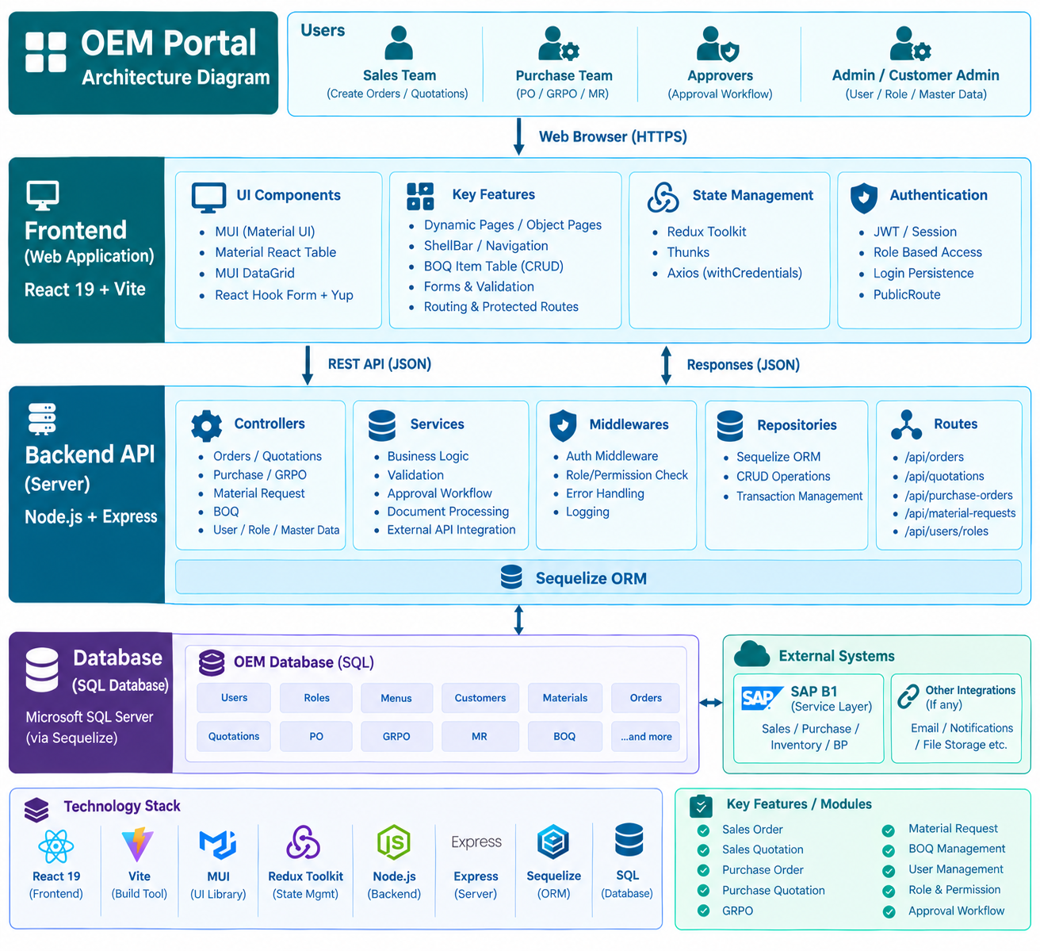
Figure 1: OEM Enterprise Architecture Diagram illustrating Frontend (React), Backend API (Node.js/Express), Database layer, and SAP B1 REST API Service Layer integration.

2.1 SAP Integration & License Optimization Architecture
The OEM Enterprise Application is architected as an intermediary layer between business users and the core SAP B1 ERP instance to enforce workflow governance and drastically optimize ERP licensing overhead.
- License Cost Optimization: Standard operational personnel do not require direct SAP user accounts or individual ERP licenses. All draft creation, validation, line-item pricing, and multi-level approvals take place within the OEM Platform.
- Service Layer API Integration: Upon reaching final approval in the OEM application, transactions are programmatically posted to SAP B1 using backend service accounts via the SAP B1 Service Layer REST APIs.
- Core Synchronized Transaction Documents: The OEM Application manages and automatically posts five primary transaction types into SAP

3. Module Specifications

3.1 Platform Admin Module
The Platform Admin module manages core tenant definitions, system navigation structures, and global authorization parameters.

Features & Technical Scope
- Company:
  - Provision and manage OEM entities and customer companies.
  - Users from one company must never be able to see or modify another company's data.
- Menu Management:
  - Dynamic navigation routing based on company assignment and role permissions.
  - Hierarchical menu definition (Parent-Child navigation tree).
  - Route guards and interface feature flags.
- Role Management:
  - Defines granular permissions (List,Create, Read, Update, Delete).
  - Functional mapping between system roles and menu visibilities.
- User Management:
  - Global user lifecycle management (Provisioning, Activation, Password Policies).
  - Multi-company association for enterprise users.

Sub-Module | Key Entities | Primary Functional Operations
Company Management | companies, company_config | Company details
Menu Management | menus, menu_permissions | Dynamic route mapping, UI tree rendering
Role Management | roles, permissions, role_permissions | Permission matrix setup, RBAC definitions
User Management | users, user_companies, user_roles | Identity management, auth strategy, sessions

3.2 OEM Internal User Operations Module
The OEM User module handles day-to-day business processes, managing the pipeline from material requests and quotation management through to purchase orders, sales orders, and goods receipt processing.

Features & Technical Scope
- Sales Order (SO):
  - Convert approved quotations into binding sales orders.
  - Track fulfillment status, line-item pricing, tax breakdowns, and scheduled delivery dates.
- Quotation:
  - Generate and issue commercial quotations to customers.
  - Support line-item discounts, margin calculations, terms & conditions, and validity periods.
- Purchase Order (PO):
  - Issue procurement orders to vendors based on approved Quotation Requests or Material Requests.
  - Manage vendor terms, delivery milestones, and line-item taxation.
- Quotation Request :
  - Request pricing proposals from potential vendors for required items/materials.
  - Compare vendor responses and convert selected bids into Purchase Orders.
- GRPO (Goods Receipt Purchase Order):
  - Receive incoming shipments against open Purchase Orders.
  - Perform quantity matching, defect checks, and inventory movement triggers.
- Material Request (MR):
  - Internal demand creation for production, maintenance, or project requirements.
  - Routes through internal approval channels prior to inventory reservation or PO creation.
- Approval Module (Internal):
  - Runtime approval engine evaluating document types (SO, PO, MR, Quotation).
  - Supports dynamic multi-level approval hierarchies based on financial thresholds and departments.

Structural Consistency Across Core Documents
Note: Across the OEM Internal User Operations module, key transactional documents—including Sales Quotation, Sales Order, Purchase Order, Purchase Quotation, and Purchase Request—follow a standardized interface and lifecycle structure. Each document consists of three core tabs: General (header information and entity metadata), Contents (line-item grid, tax codes, discounts, and summary totals), and Attachments (supporting documentation). Furthermore, all five document types share a common approval workflow and automatic backend SAP B1 Service Layer posting behavior upon final authorization.

Document Type | Source Entity | Target Entity | Key Lifecycle Statuses
Material Request | BOM | Purchase Request | Draft, Pending Approval, Approved, Fulfilled, Rejected
Sales Quotation | Customer Details | Sales Order | Draft, Sent, Evaluated, Closed
Purchase Order | Purchase Request | GRPO | Draft, Pending Approval, Approved, Issued, Received, Closed
Sales Order | Customer Details | Delivery / Invoice | Draft, Pending Approval, Confirmed, Processing, Shipped
GRPO | Purchase Order | Inventory Ledger | Pending Inspection, Accepted, Partial Receipt, Rejected

3.3 Customer Admin Portal
The Customer Admin Portal provides external clients with administrative and operational control over their interactions with the OEM platform, including project oversight and custom internal approval rules.

Features & Technical Scope
- Customer User Management:
  - Self-administration of client staff accounts.
  - Assign internal roles to customer users (e.g., Buyer, Project Manager, Finance Approver).
- Customer Role Management:
  - Define custom permission sets tailored to the client's internal organization structure.
- Project Management:
  - Track active client projects, linked milestones, and related commercial documents (Sales Orders, Quotations).
  - Monitor document status and fulfillment schedules in real time.
- Approval Template Engine:
  - Client-configurable rules for approving orders and quotations before formal submission to the OEM.
  - Define spend thresholds, approval chains, and delegate approvers.

Feature Area | Key Data Inputs | Business Purpose
Customer User Setup | Contact Info, Department, Allocated Roles | Secure client access control and audit accountability
Customer RBAC | Action matrix (View SO, Approve Quote, Raise MR) | Limit customer staff actions based on authority
Project Workspace | Project Name, Budget, Timeline, Linked SOs | Real-time visibility into order execution vs. project goals
Approval Templates | Spend Limits, Approver Sequences, Doc Types | Enforce client-side internal governance prior to ordering

6. Non-Functional Requirements & Architecture Standards

Security & Compliance
- Authentication: Stateless JWT authentication with short-lived access tokens and secure refresh token rotation. Supports SSO (OIDC/SAML2) for enterprise tenants.
- Authorization: Multi-tenant RBAC enforced at API gateway and service layers.
- Data Isolation: All queries must explicitly filter by company_id / tenant_id context. Row-Level Security (RLS) policies implemented at database level where applicable.

Performance & Scalability
- Database Indexing: Composite indexes on (company_id, status, created_at) for operational lists.
- Pagination: Mandatory cursor-based or server-side pagination for long lists (SO, PO, Material Requests).
- Asynchronous Processing: Long-running processes (PDF generation, bulk material requests, email notifications) handled via background queues.

7. API Documentation, Connection Flow & UI Visual Reference

7.1 API Environments

API / Service Type | Base URL
Primary / Supplied API | https://sapoemapi.hlbmeonline.com:8005/api/v1

7.2 Connection Flow & End-to-End Sequence
- Client Layer: Client application initiates HTTPS REST requests containing JWT bearer tokens and X-Tenant-ID context.
- API Gateway: Performs TLS termination, rate limiting inspection, and validates the JWT signature before routing downstreams.
- Tenant & Security Service: Evaluates role permissions (RBAC) and verifies tenant authorization against access policies.
- Application Services Execution:
  - Operations Engine: Processes business operations (SO/PO generation, stock reservations).
  - Workflow Engine: Checks approval thresholds and manages state transitions.
- Data Layer Persistence & SAP ERP Posting: Executes transactional database queries in PostgreSQL with mandatory company_id tenant isolation scope. Upon final approval of transactional workflows, the backend system automatically posts the target document (Sales Order, Sales Quotation, Purchase Order, Purchase Quotation, or Purchase Request) to SAP B1 via the SAP Service Layer API using a centralized service account.
- Response Cycle: Returns formatted JSON payloads, triggers asynchronous background jobs (notifications, audit logging), and finishes request execution.

7.3 Screen by screen documentation
This section serves as a visual reference and structural blueprint for the core interface screens across all three primary portals—Platform Admin, OEM Internal Operations, and Customer Admin Portal—as well as key system engines like the Dynamic Approval Rule Configuration. These screen references outline layout structures, user interaction paths, component placements, and workflow visibility expectations to guide design and development teams in building consistent, user-centric interfaces.
7.3.1. Login Screen
Authenticate users

Figure 2: Authentication portal landing interface demonstrating multi-tenant sign-in and user
authentication workflow.

7.3.1.1 Authentication Workflow & Login API Integration
User authentication is initialized through the primary API service on the sign-in screen. The table below details the interaction sequence and corresponding endpoint mapping for credential validation:

HTTP Method | API Endpoint | Request Payload | Response / Output
POST | /auth/login | { email, password } | JWT Access Token, Refresh Token, User Profile & Role Context

7.3.1.1 Login API Mapping & Authentication Flow
The login screen initiates user authentication via the primary API service. Below is the API endpoint mapping and interaction lifecycle for authenticating user credentials:

HTTP Method | API Endpoint | Request Payload | Response / Output
POST | /auth/login | { email, password } | JWT Access Token, Refresh Token, User Profile & Role Context

UI-to-API Interaction Flow & Session Management:
- Credential Entry & Submission: The user inputs their email address and password on the UI login panel and submits the form.
- Authentication Processing: The client application submits a POST request to /auth/login. The backend verifies credentials against stored password hashes and validates tenant association.
- Token Issuance & Session Initialization: Upon successful authentication, the backend returns a short-lived JWT access token and refresh token along with authorized tenant/company scopes and RBAC permissions.
- State Persistence & Navigation: The React frontend stores the authentication state in Redux Toolkit, attaches the bearer token to subsequent HTTP requests via Axios interceptors, and redirects the user to their designated portal dashboard.

7.3.2. Dashboard
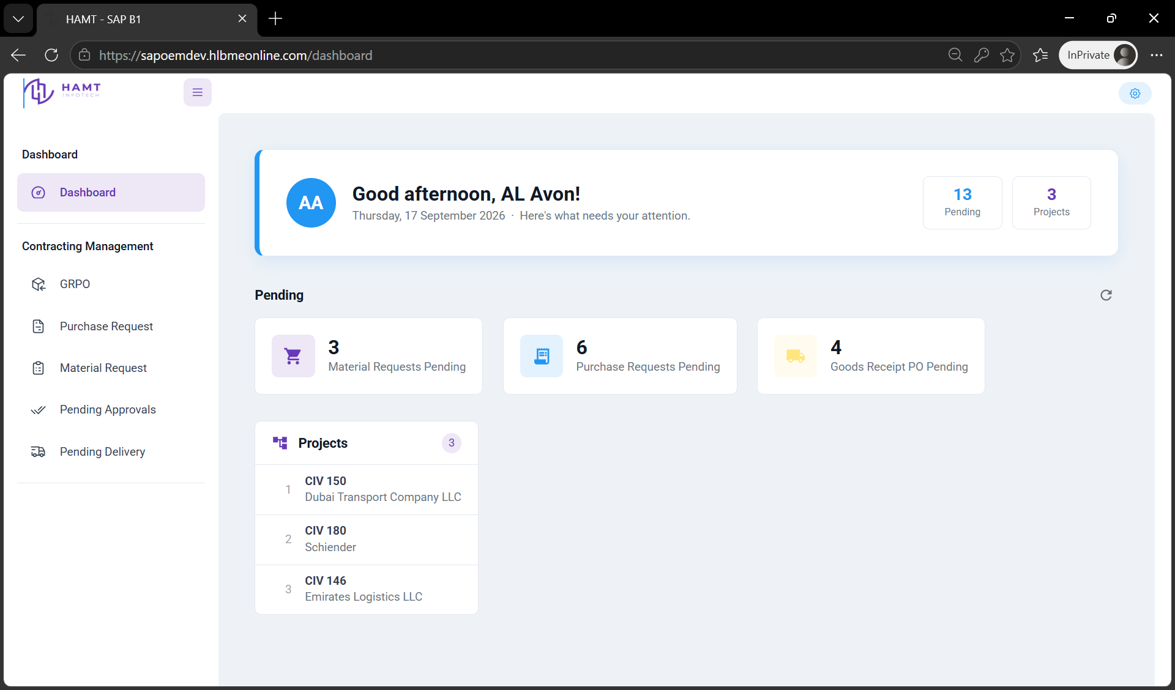
Figure 3: Platform operations executive dashboard providing high-level KPIs, pending request alerts, and active project overviews.
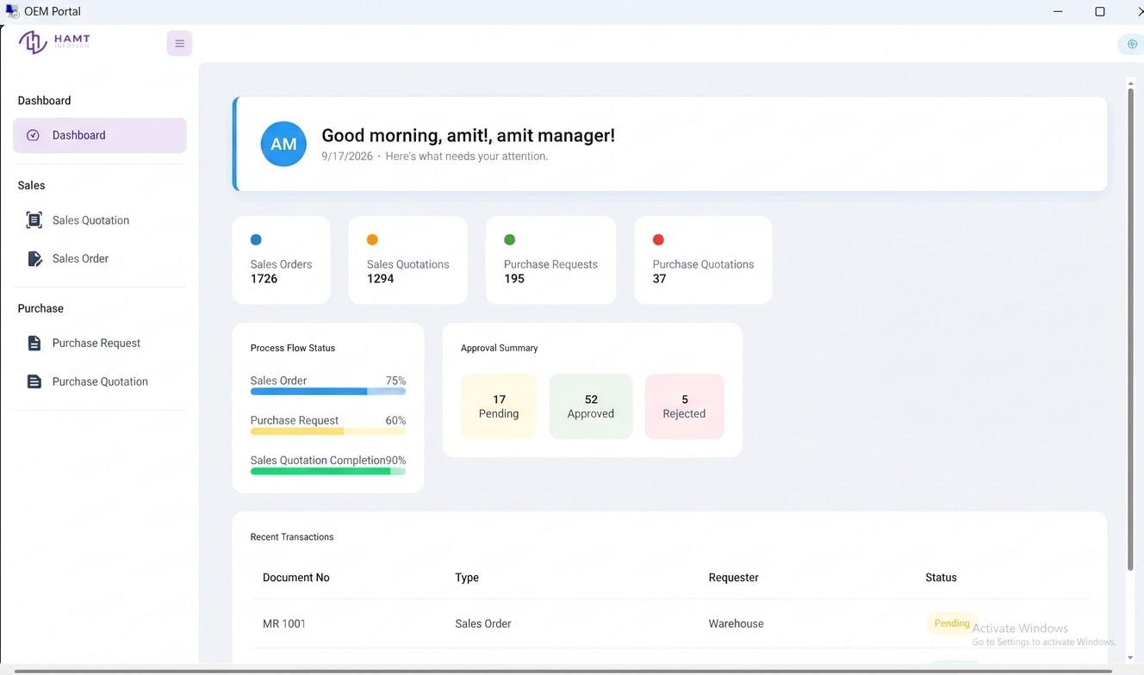
Figure 4: Sales and procurement analytics workspace detailing process flow completion metrics and pending approval queues.
7.3.3. Sales Quotation
7.3.3.1 Sales Quotation List
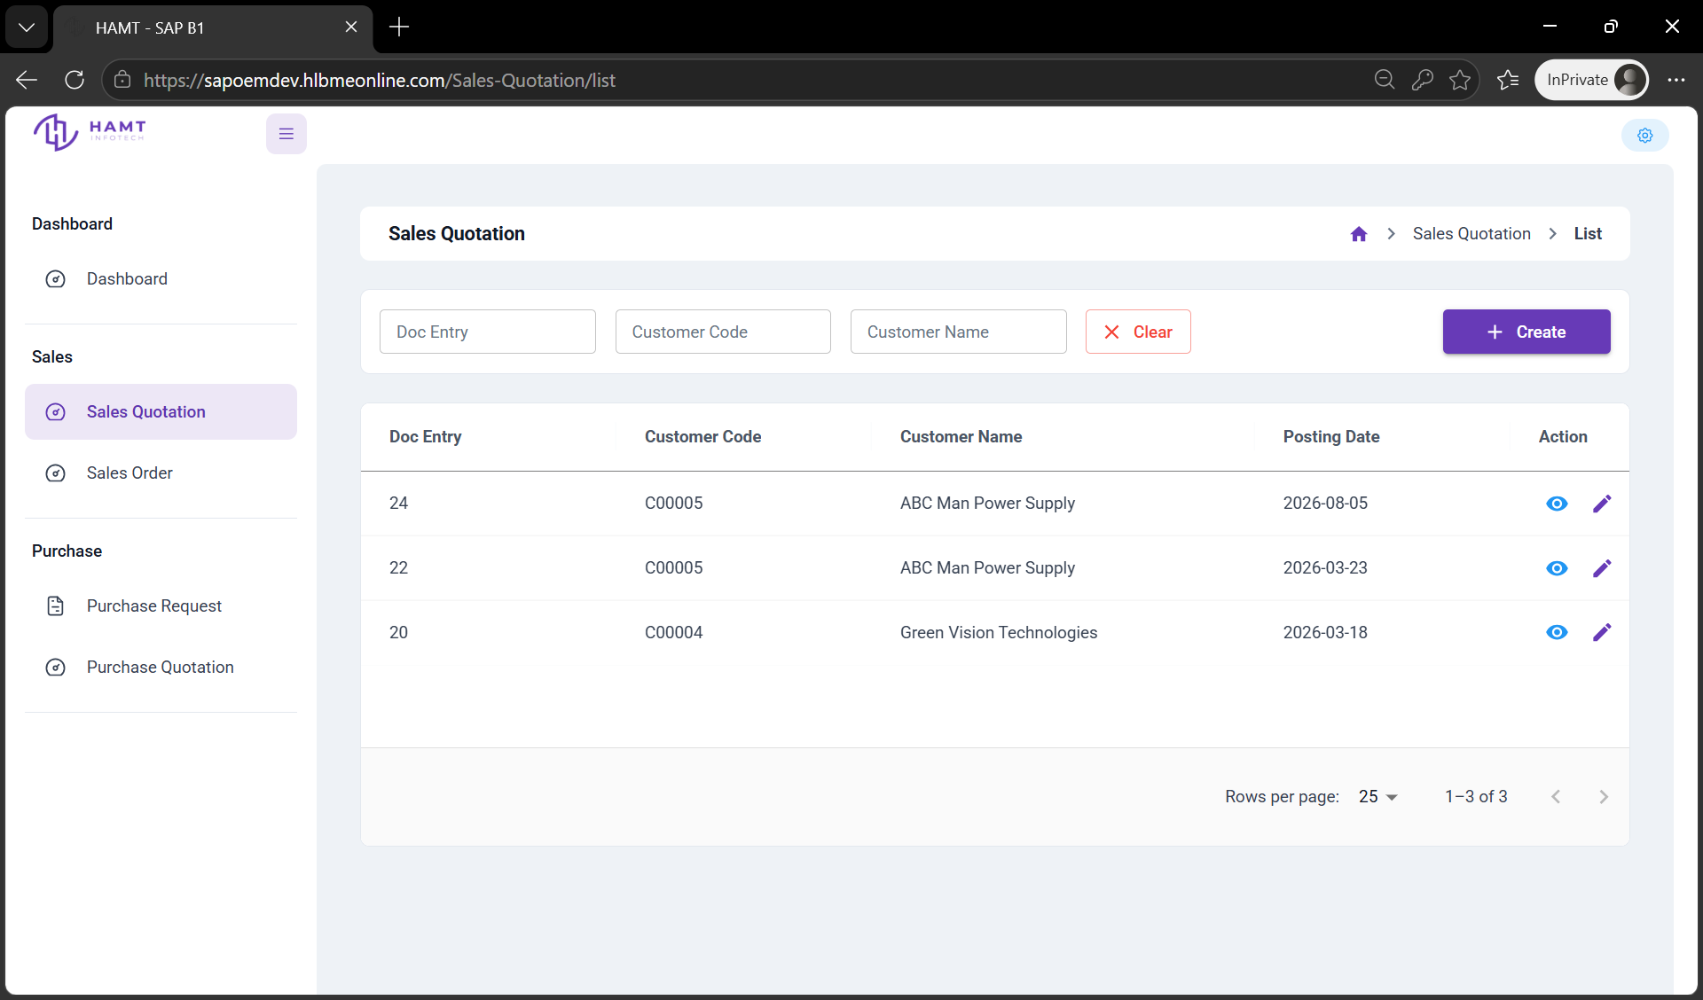
Figure 5: Sales Quotation management view containing document filtering options, status indicators, and record entry controls.
7.3.3.2 Sales Quotation Create (General Tab)
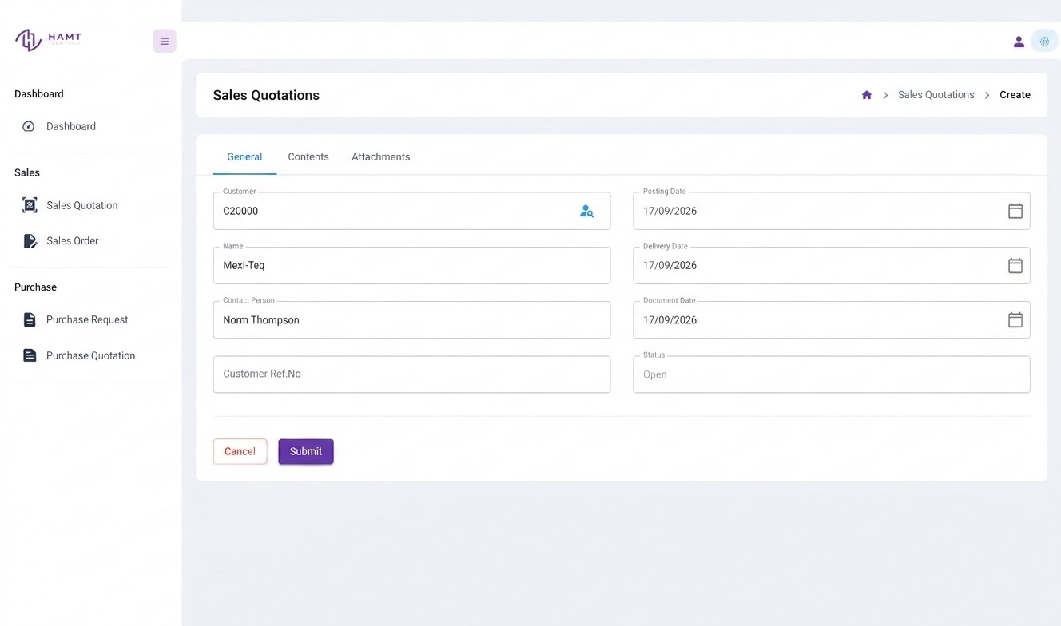
Figure 6: Primary Sales Quotation creation interface for managing header details, customer selection, posting dates, and document status.
7.3.3.3 Sales Quotation Create (Content Tab)
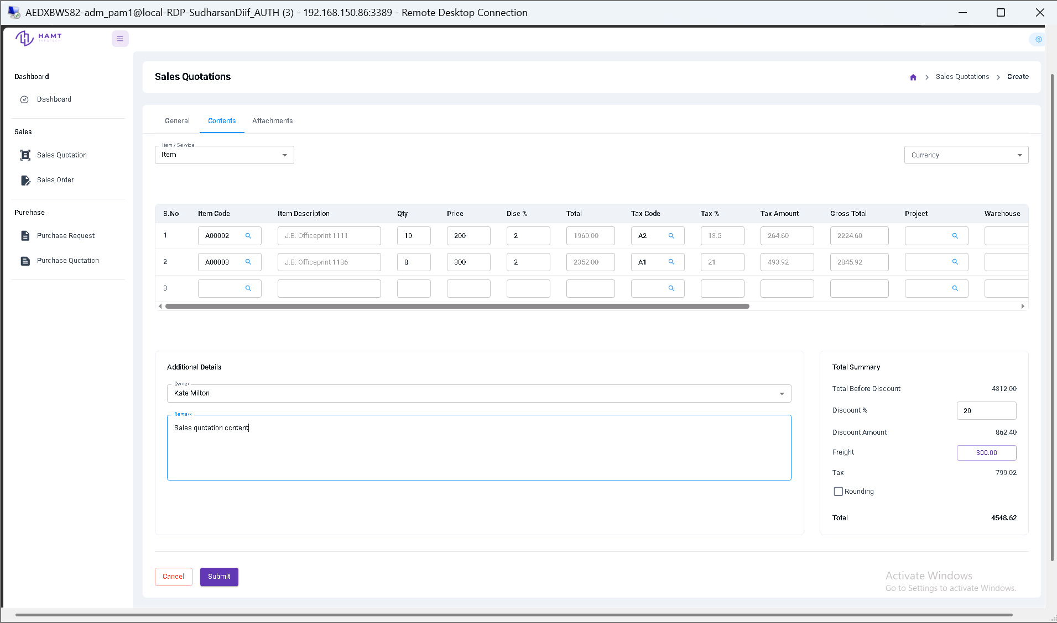
Figure 7: Line-item management grid for configuring items, quantities, unit prices, discounts, tax codes, freight charges, and summary totals.
7.3.3.4 Sales Quotation Create (Attachment Tab)
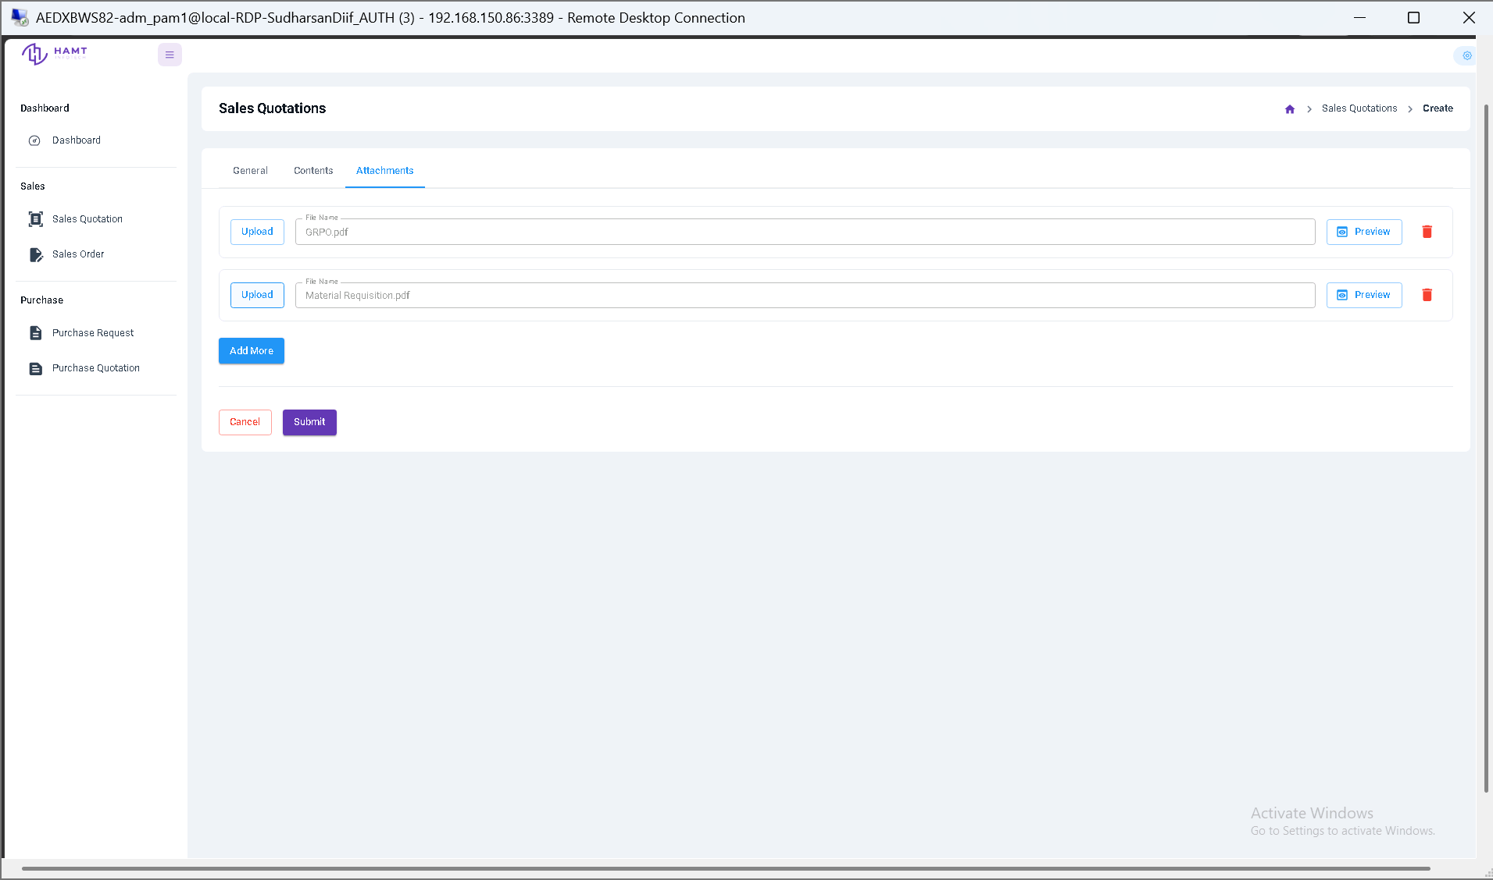
Figure 8: Sales Quotation attachment management panel for uploading and previewing supporting documentation.
7.3.3.5 Sales Quotation Create (Customer Selection)
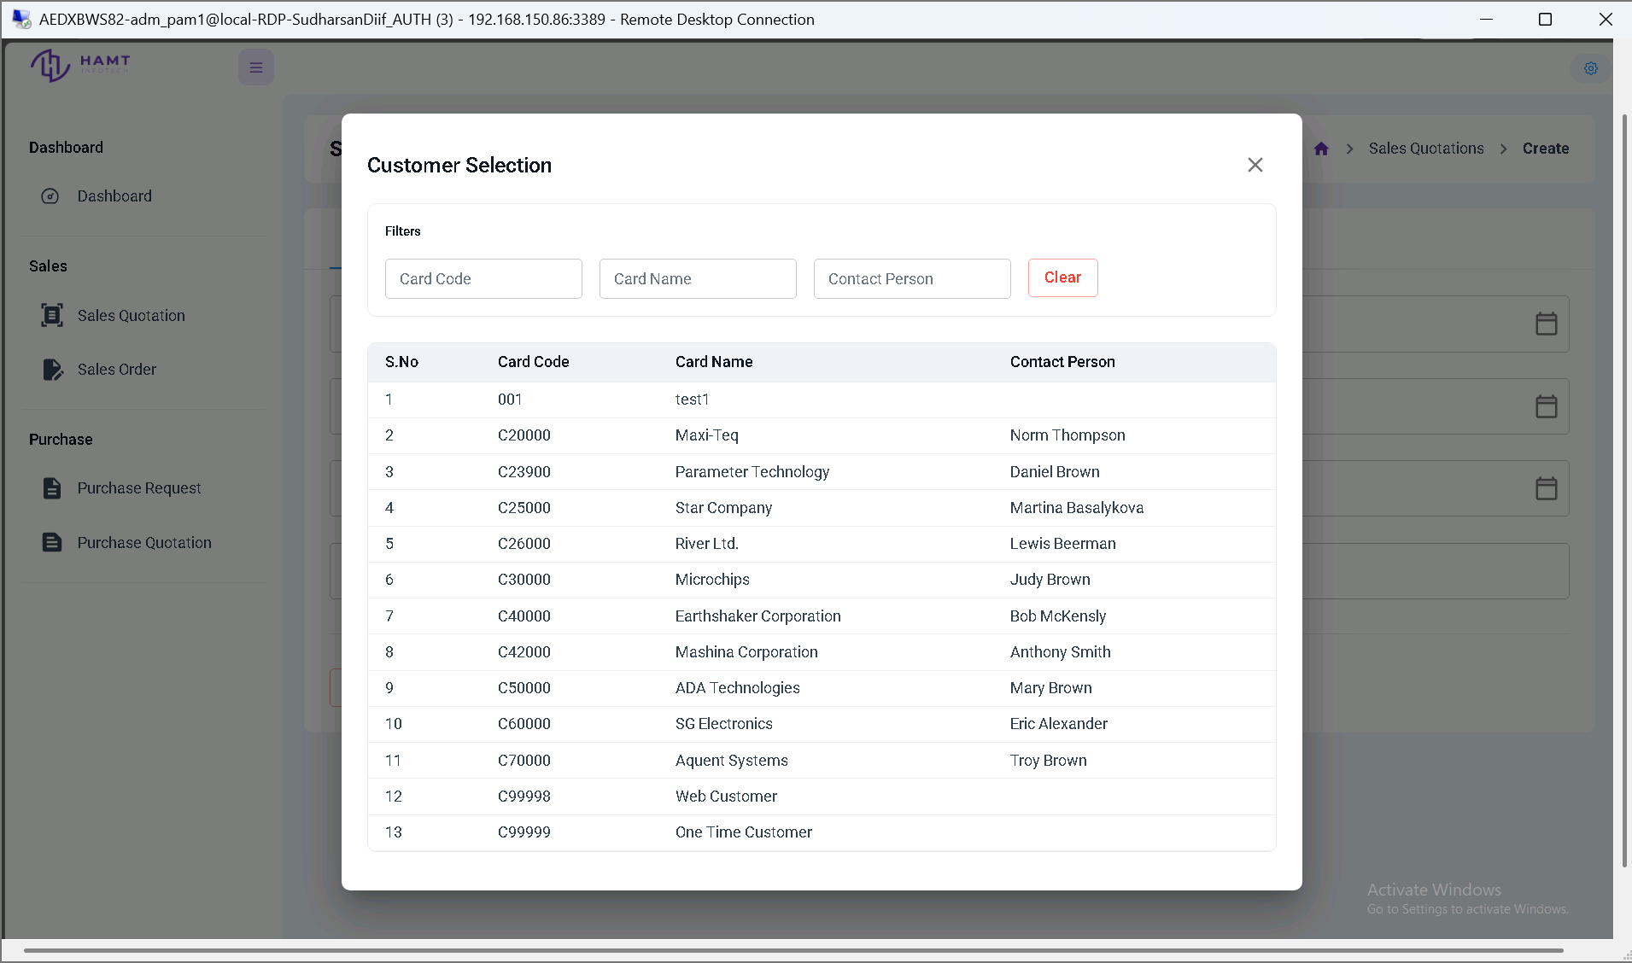
Figure 9: Customer lookup and selection modal supporting filtering by card code, name, and primary contact person.
7.3.3.6 Sales Quotation Create (Tax Code Selection)
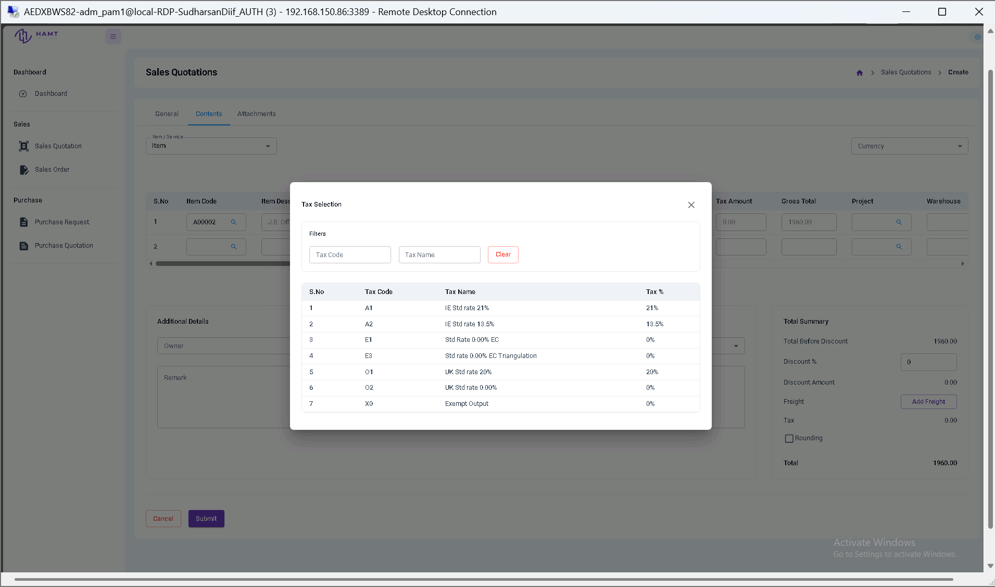
Figure 10: Tax code selection modal displaying dynamic tax rate lookup rules based on regional jurisdiction.
7.3.3.7 Sales Quotation Create (Freight Details)
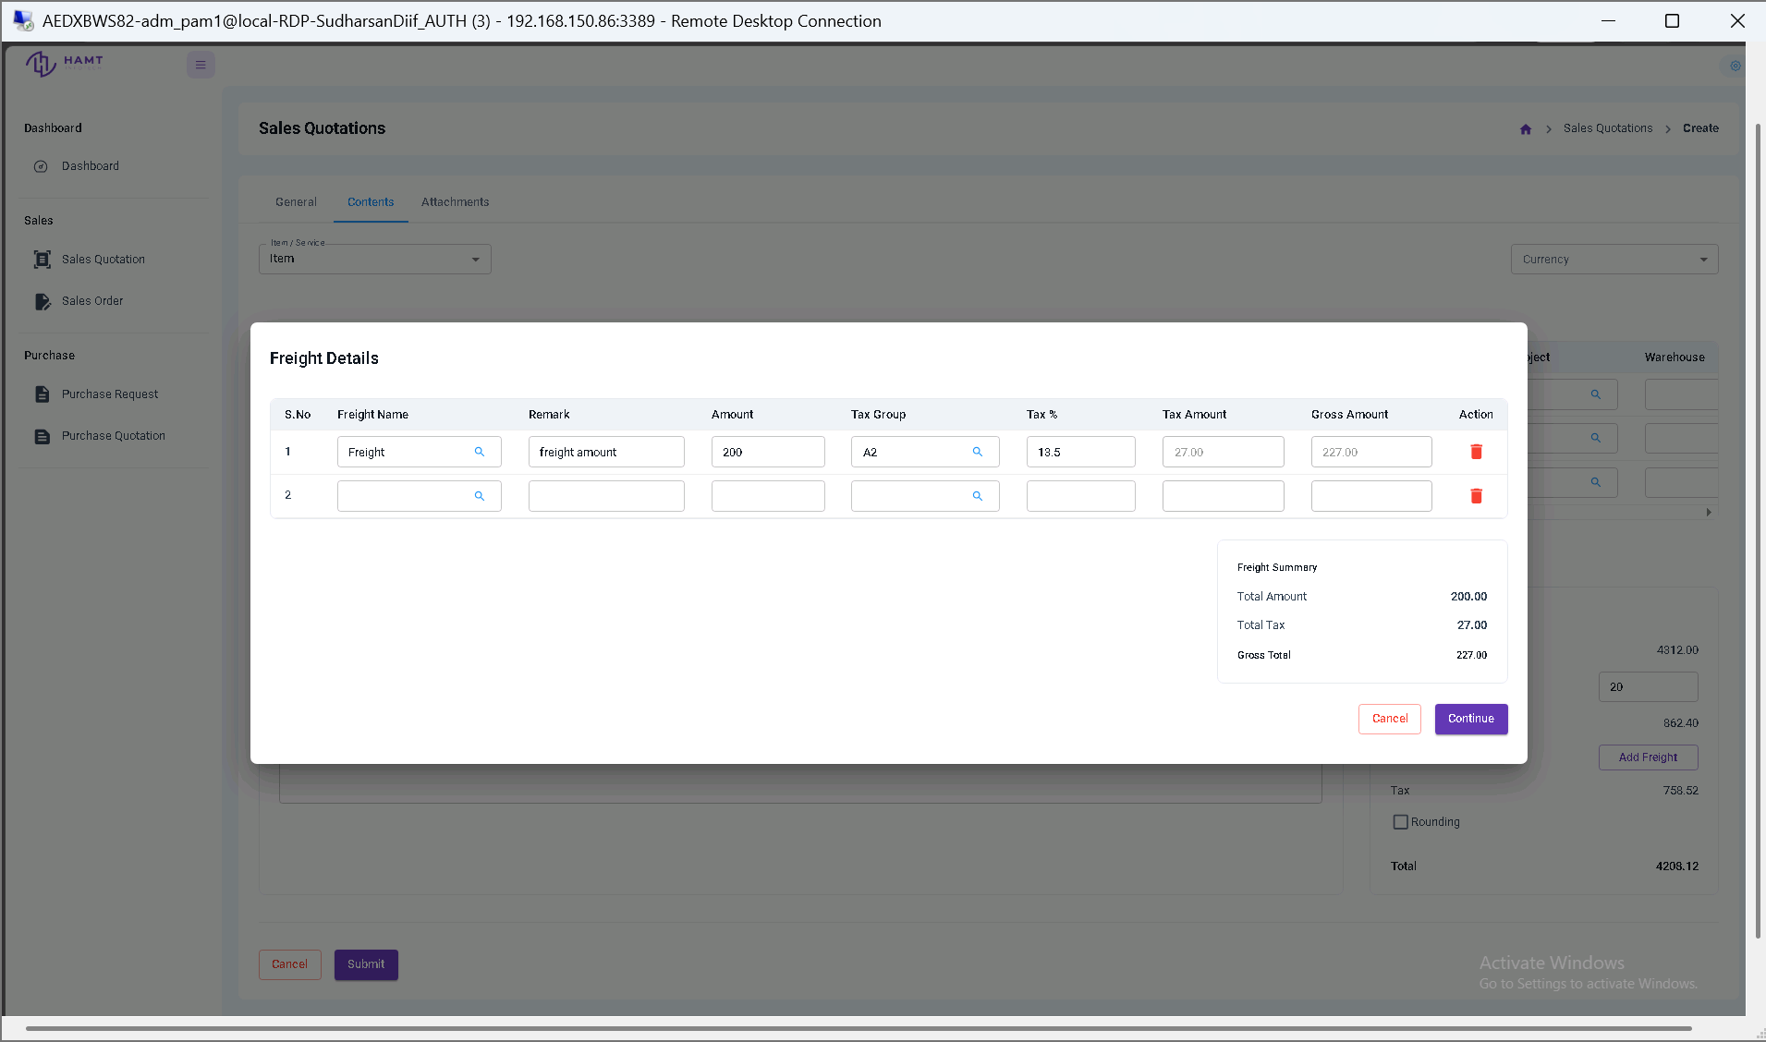
Figure 11: Freight details configuration modal displaying additional delivery charges, tax calculations, and gross summary totals.
Note on Sales Orders & Other Core Documents: As outlined in Section 3.2, core transactional documents—including Sales Orders, Purchase Orders, Purchase Quotations, and Purchase Requests—share the exact same three-tab UI structure (General, Contents, Attachments) and item selection modals as demonstrated above for Sales Quotation. Separate UI screenshots for Sales Orders are omitted to avoid redundancy across structurally identical views.

7.3.3.8 Material Request Creation
The Material Request creation screen enables internal users to submit demand requisitions for production, maintenance, or project requirements prior to inventory allocation or Purchase Order generation. The requisition process follows the standardized document structure comprising three distinct functional areas:
- General Tab (Header Metadata): Captures primary requisition parameters, including Customer/Entity selection, Requisition Number, Requisition Date & Time, Project Code/Name, Required Delivery Date, and BOM (Bill of Materials) reference number.
- Contents Tab (Line Items & Stock Demand): Defines line-item demand specifications including Item Code, Item Description, Required Quantities, Warehouse location, and linked Project milestones.
- BOM Selection & Item Loading Workflow: Users select a customer and project code, which dynamically filters the available Bill of Materials (BOM) options. Selecting a BOM from the filtered list automatically populates the item grid with the required materials.
- Workflow Lifecycle & Approvals: Upon draft submission, requisitions transition to Pending status and enter the dynamic runtime approval engine. Once authorized across defined approval stages, the request moves to Approved and automatically posts to SAP B1 via the Service Layer REST API for downstream PO generation or fulfillment.
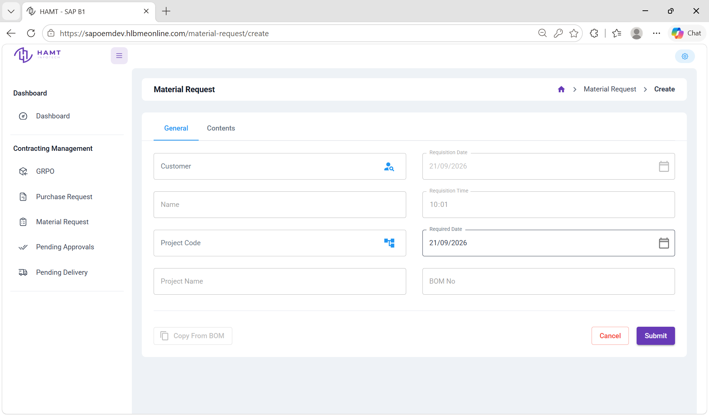
Figure 12: Material Request header creation interface for configuring requisition metadata and project associations.
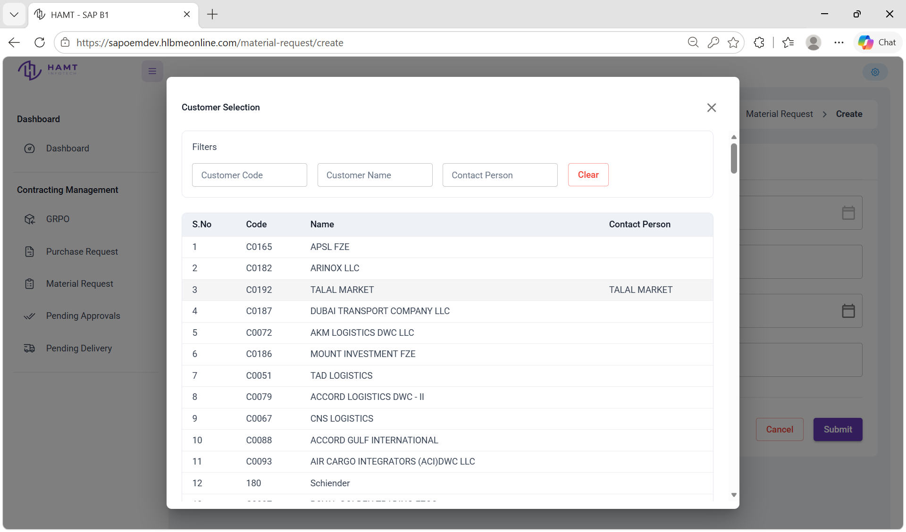
Figure 13: Customer selection modal for filtering and assigning client accounts to a material request.
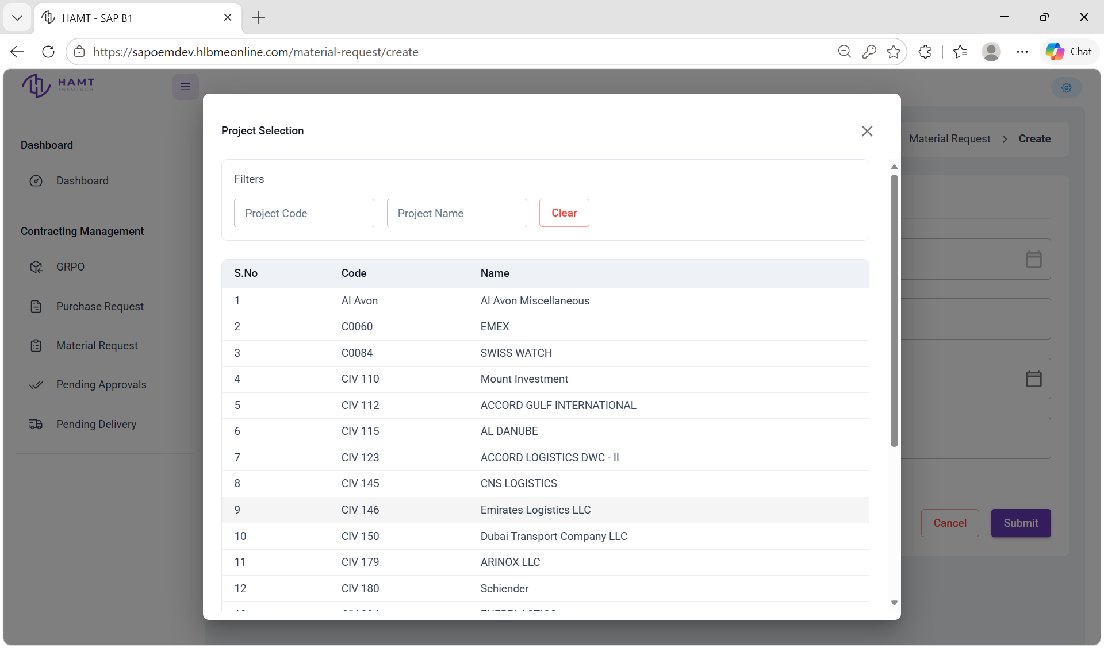
Figure 14: Project selection dialog supporting project lookup and binding for demand allocations.
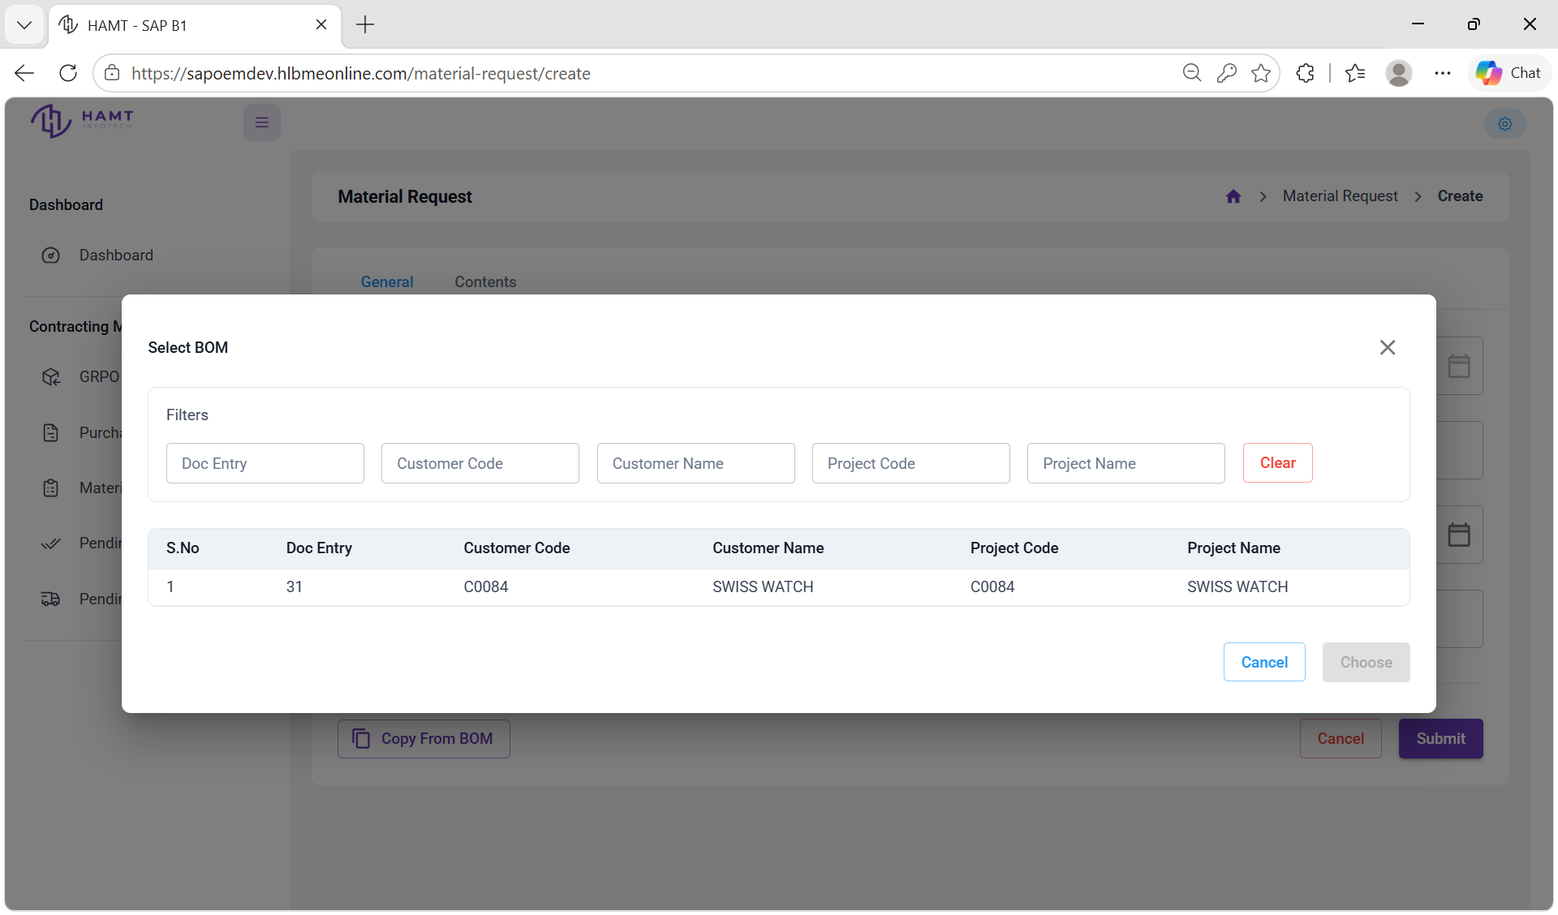
Figure 15: Bill of Materials lookup dialog filtered dynamically by customer and project assignments.
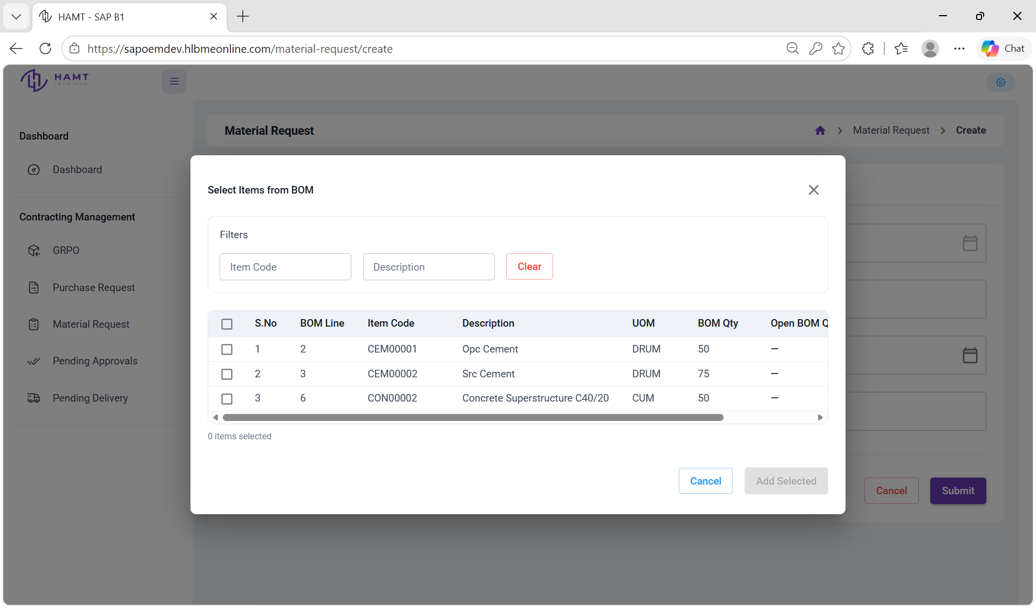
Figure 16: BOM line-item selection modal for loading required raw materials into the request grid.
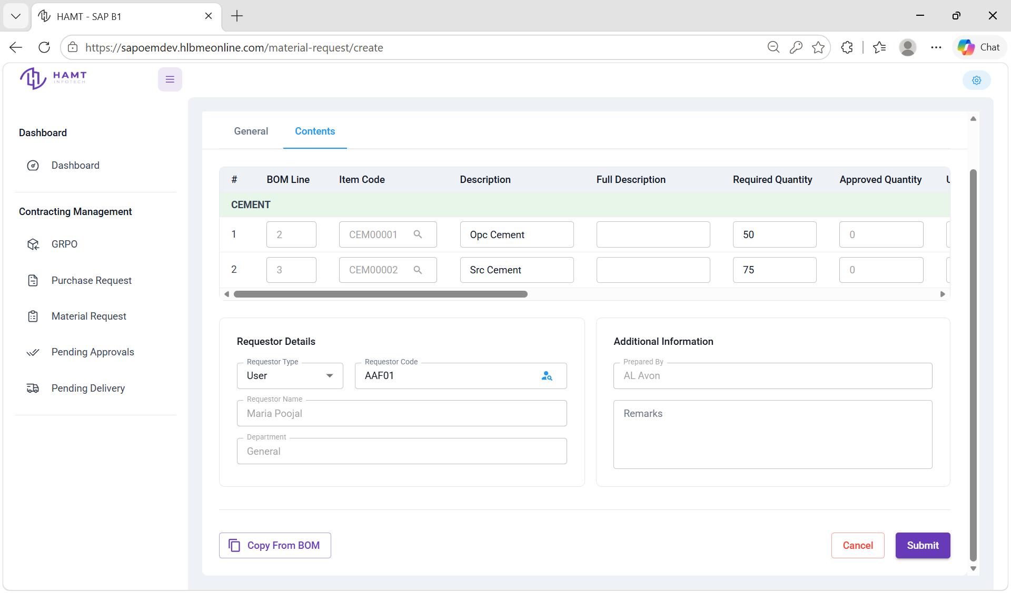
Figure 17: Material Request line-item management grid with populated BOM items and requester details.

Transactional Flow & Tracking Overview
Note: In the OEM application, transactional workflow progression follows a defined hierarchy across core operational documents: Material Requests and Purchase Requests are created based on Bill of Materials (BOM) selections, while Goods Receipt Purchase Orders (GRPO) are generated directly from open Purchase Orders. To facilitate operational visibility, pending Purchase Requests and Purchase Orders can be monitored in real time within the Pending Delivery tab. Furthermore, all Material Requests submitted with a Pending Approval status automatically route to the Pending Approvals tab, where designated and authorized users can review, inspect, edit, approve, or reject them.

7.3.3.9 Pending Approvals
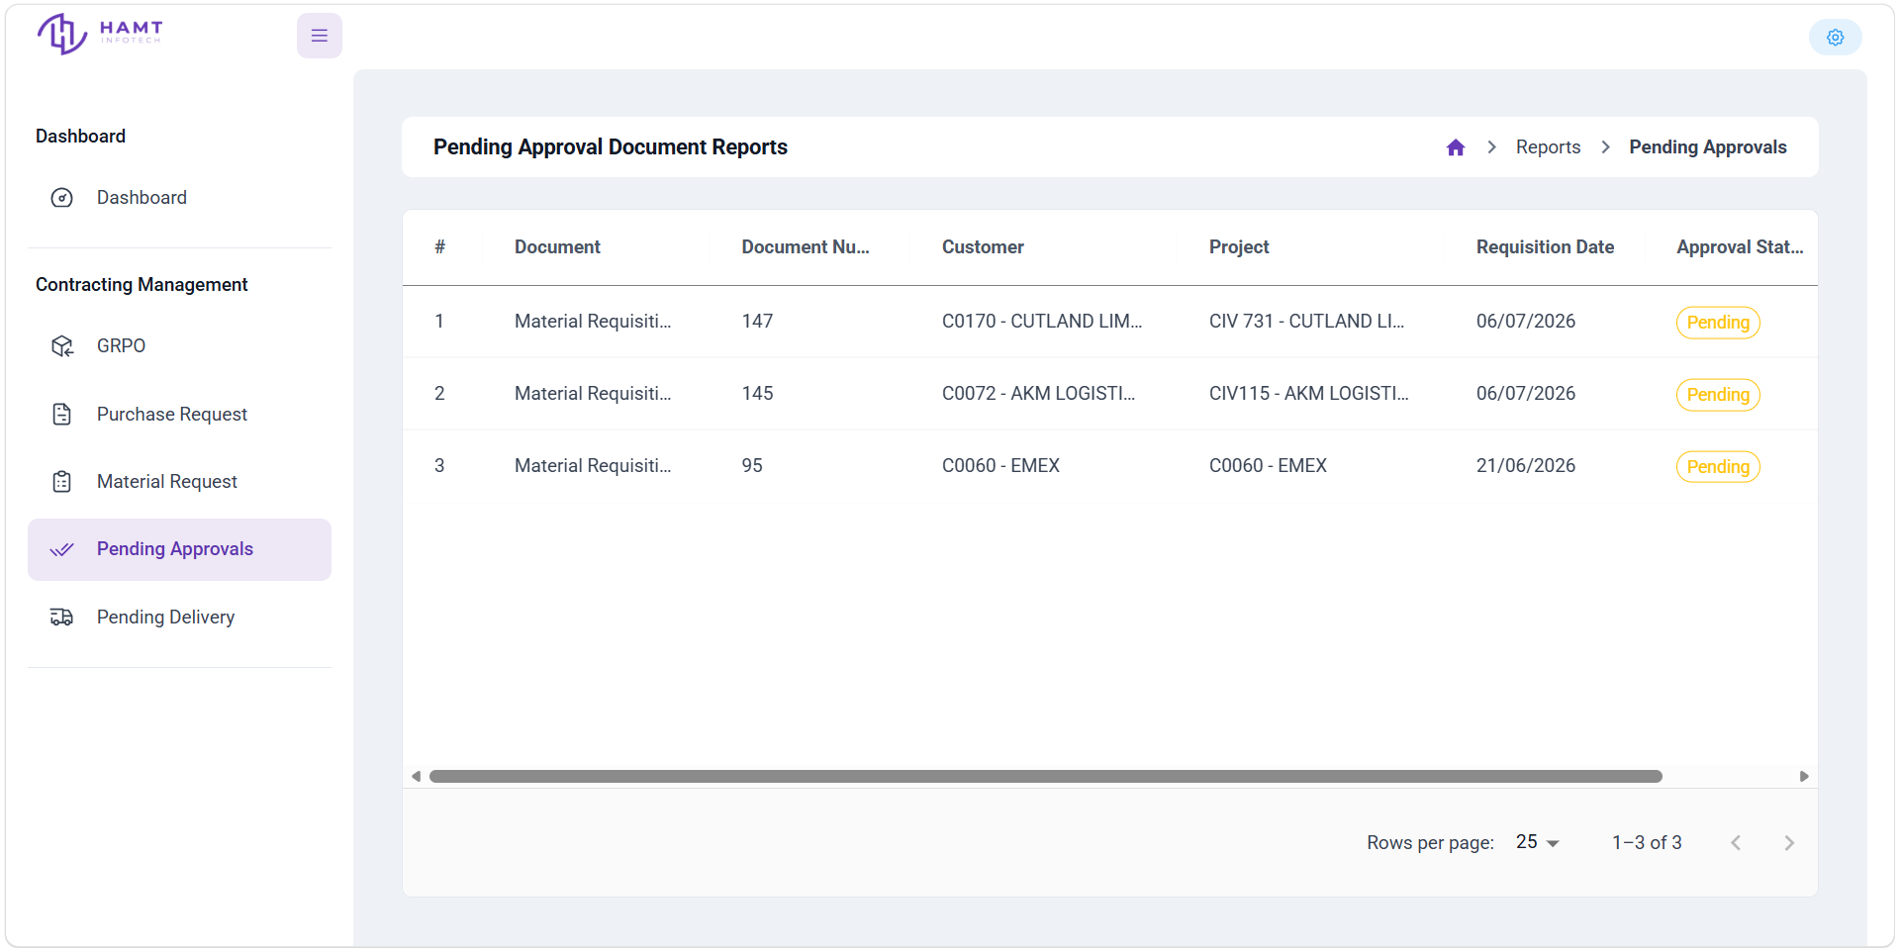
Figure 18: Pending approval document reports table displaying submitted requisitions awaiting authorization.
7.3.3.10 Pending Approval Edit screen
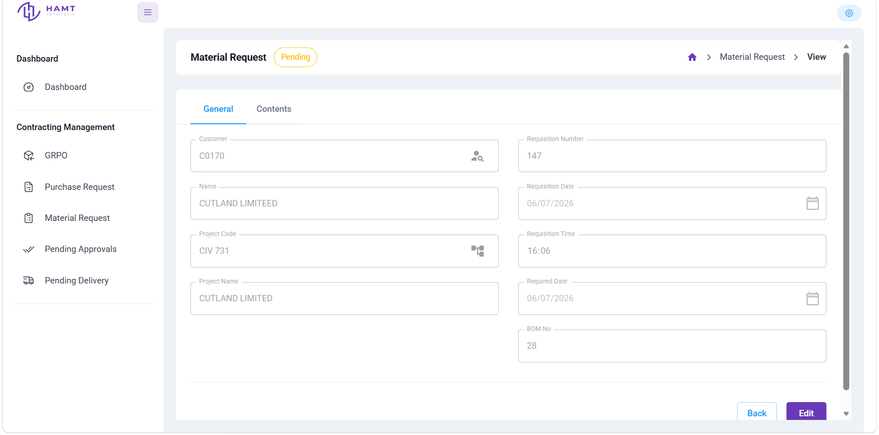
Figure 19: Detailed view of a pending Material Request displaying requisition fields and edit options.
7.3.3.11 Pending Delivery
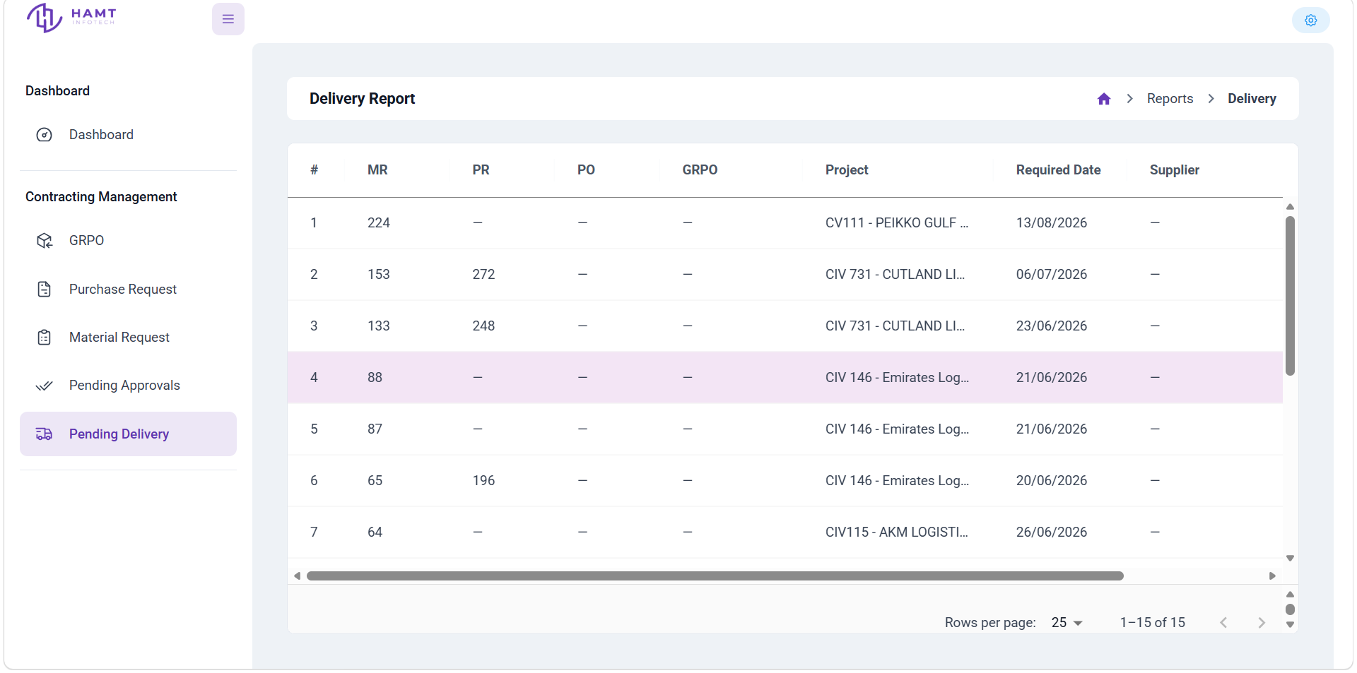
Figure 20: Pending delivery report tracking document pipeline progression across procurement and fulfillment stages.

7.3.3.12 Admin Overview Dashboard
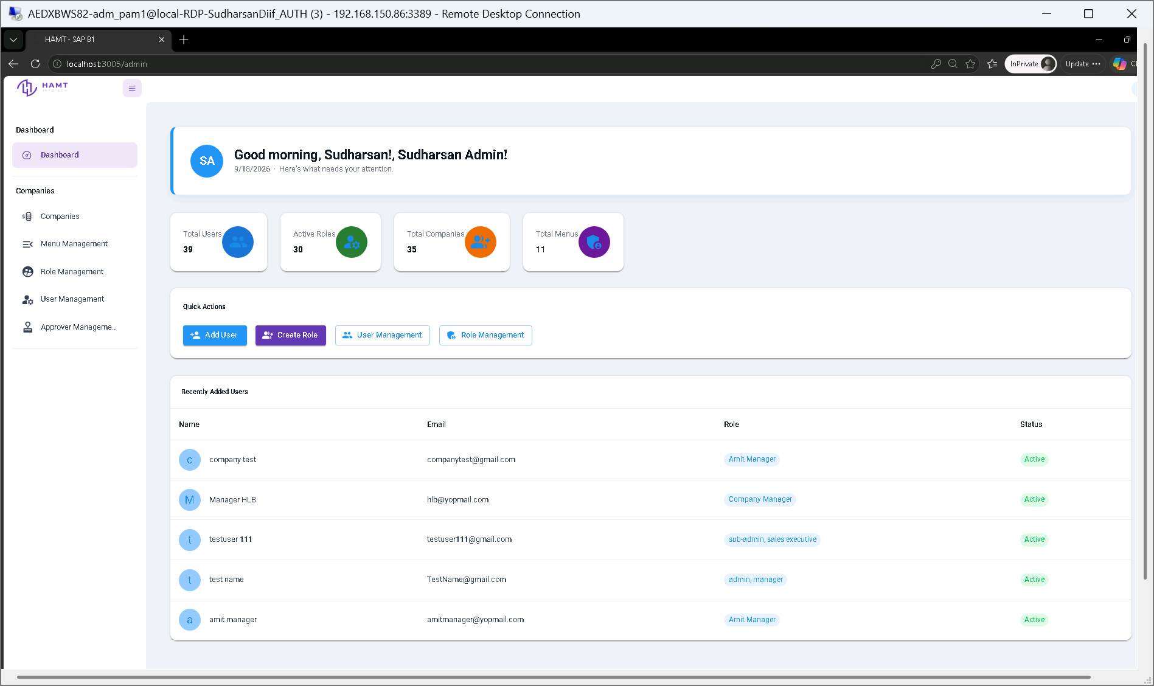
Figure 21: Admin overview dashboard featuring high-level metrics for users, active roles, tenant companies, dynamic menus, and quick-action shortcuts.

7.3.3.13 Company Management List
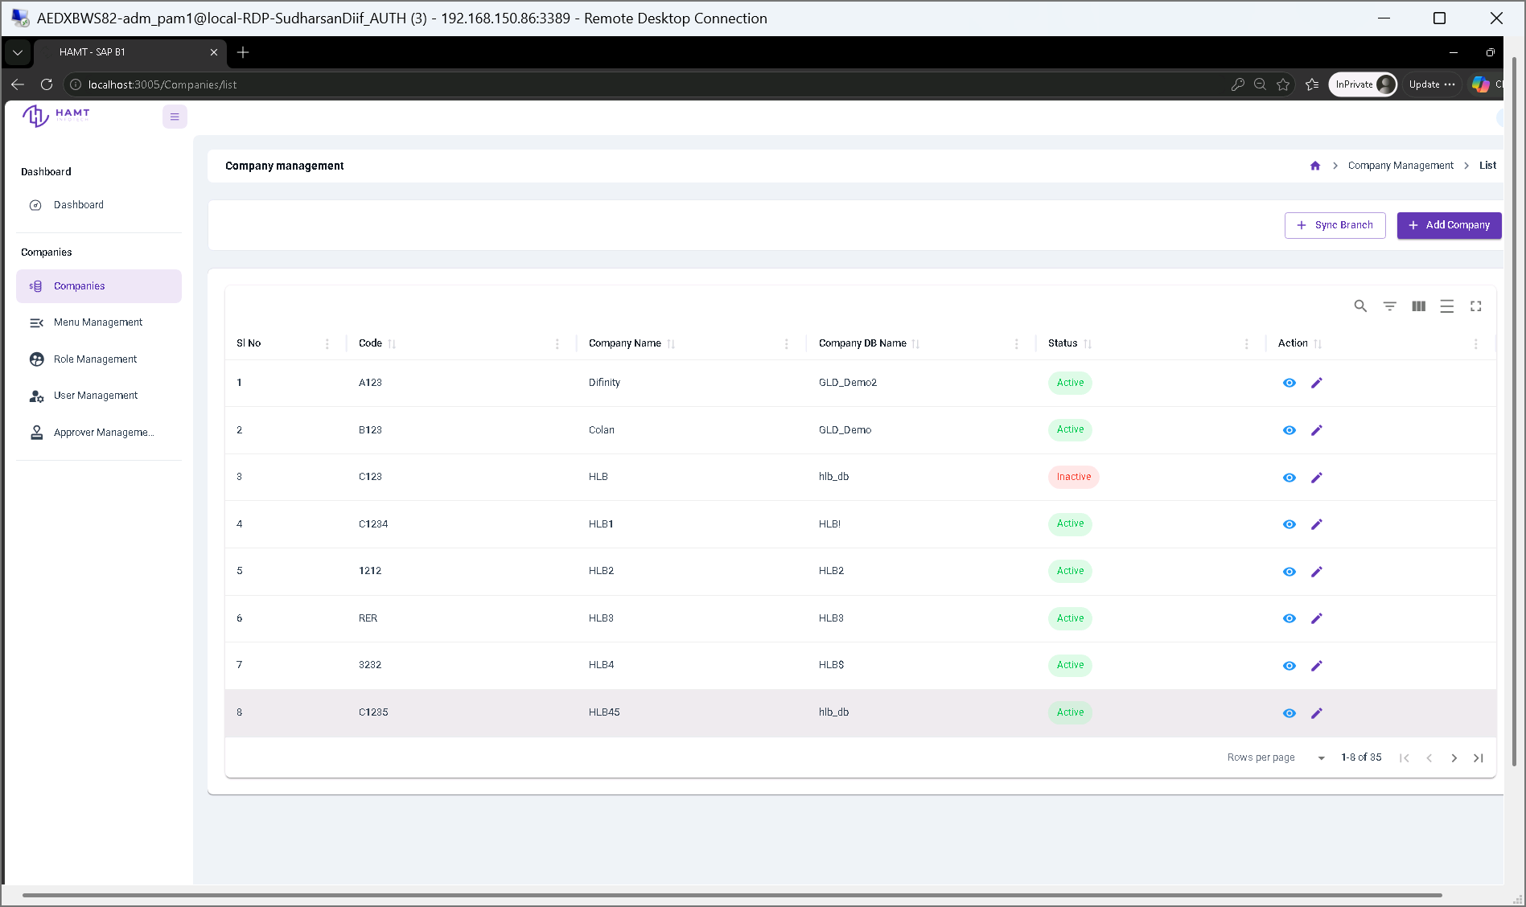
Figure 22: Company management table view showing registered multi-tenant companies, database mapping, status indicators, and sync controls.

7.3.3.14 Create New Company
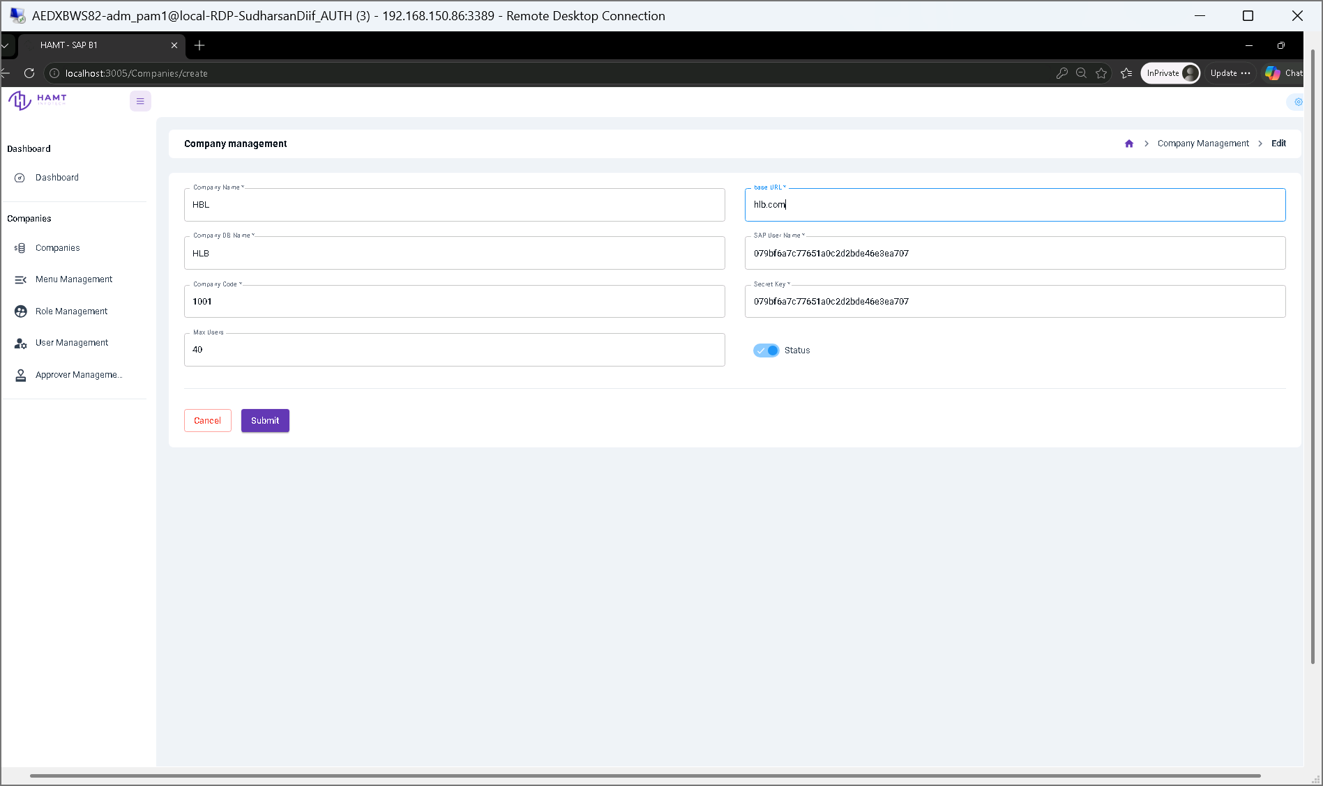
Figure 23: Tenant company registration form for configuring base API URLs, database parameters, secret keys, and user limits.

7.3.3.15 Edit Company & Branch Setup
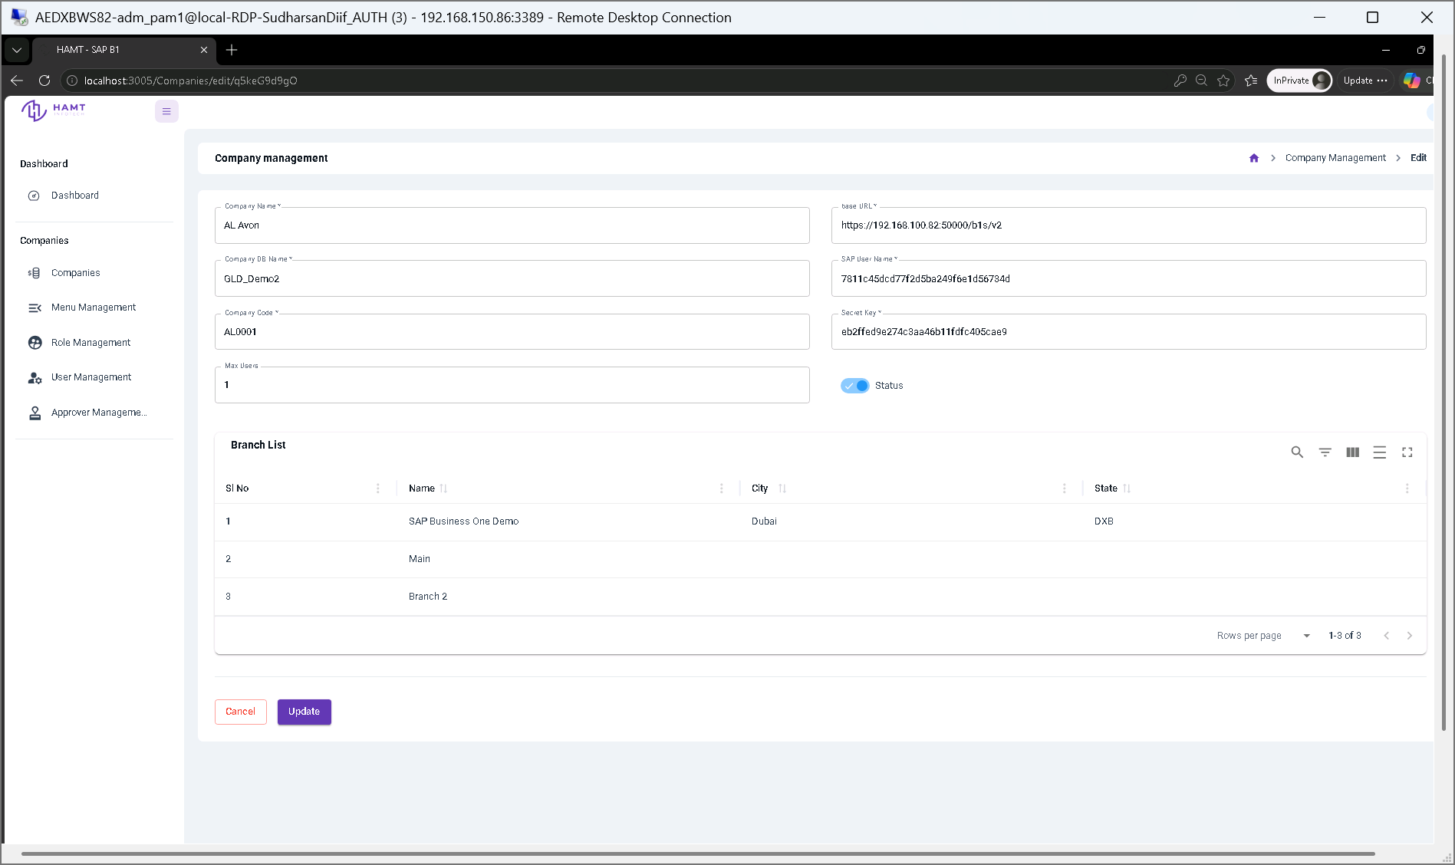
Figure 24: Company configuration edit screen displaying connection settings alongside associated branch locations and status toggles.

7.3.3.16 View Company Details
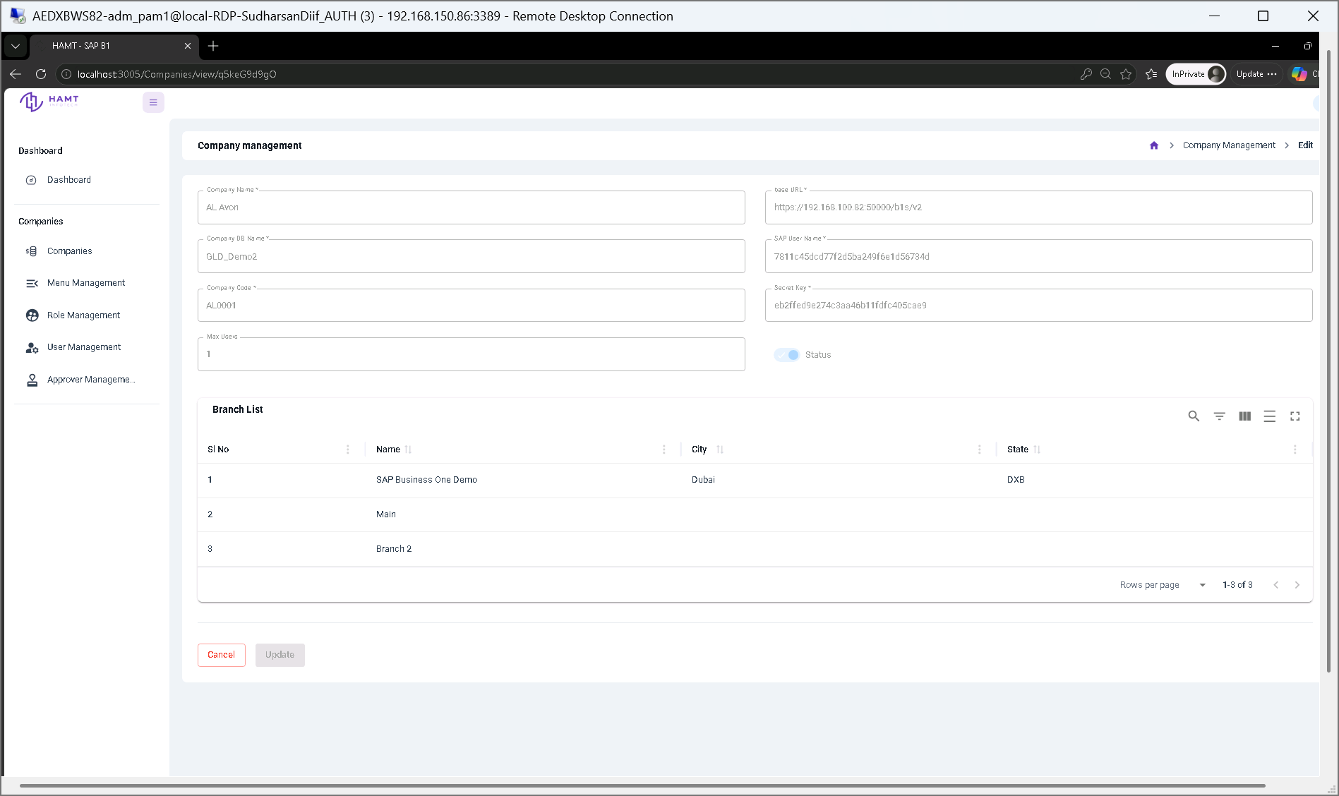
Figure 25: Read-only view of tenant company configurations, API endpoints, credentials, and mapped branch lists.

7.3.3.17 Menu Management List
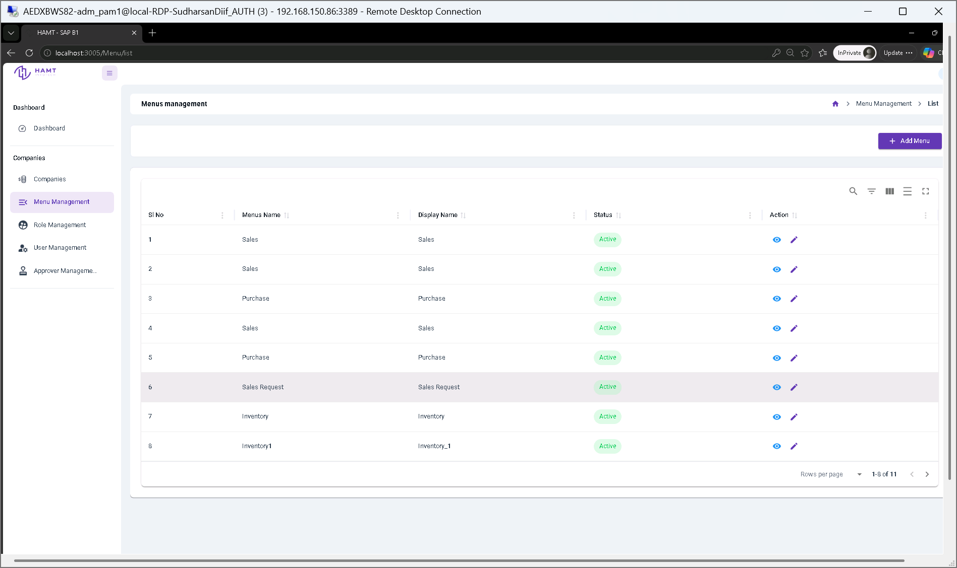
Figure 26: Menu management directory displaying navigation tree structures, internal names, display labels, and active status.

7.3.3.18 Create Menu Item
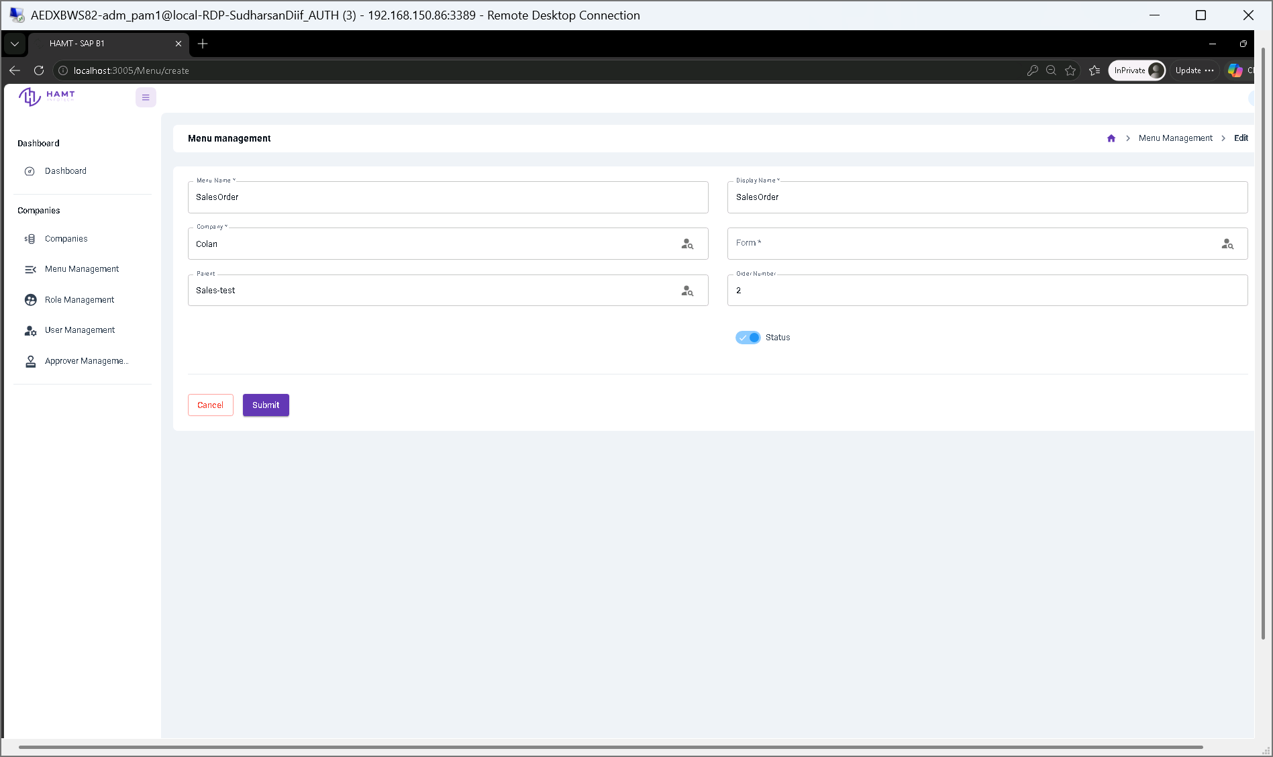
Figure 27: Form interface for defining new navigation menus, parent-child visual hierarchies, route ordering, and target forms.

7.3.3.19 Edit Menu Configuration
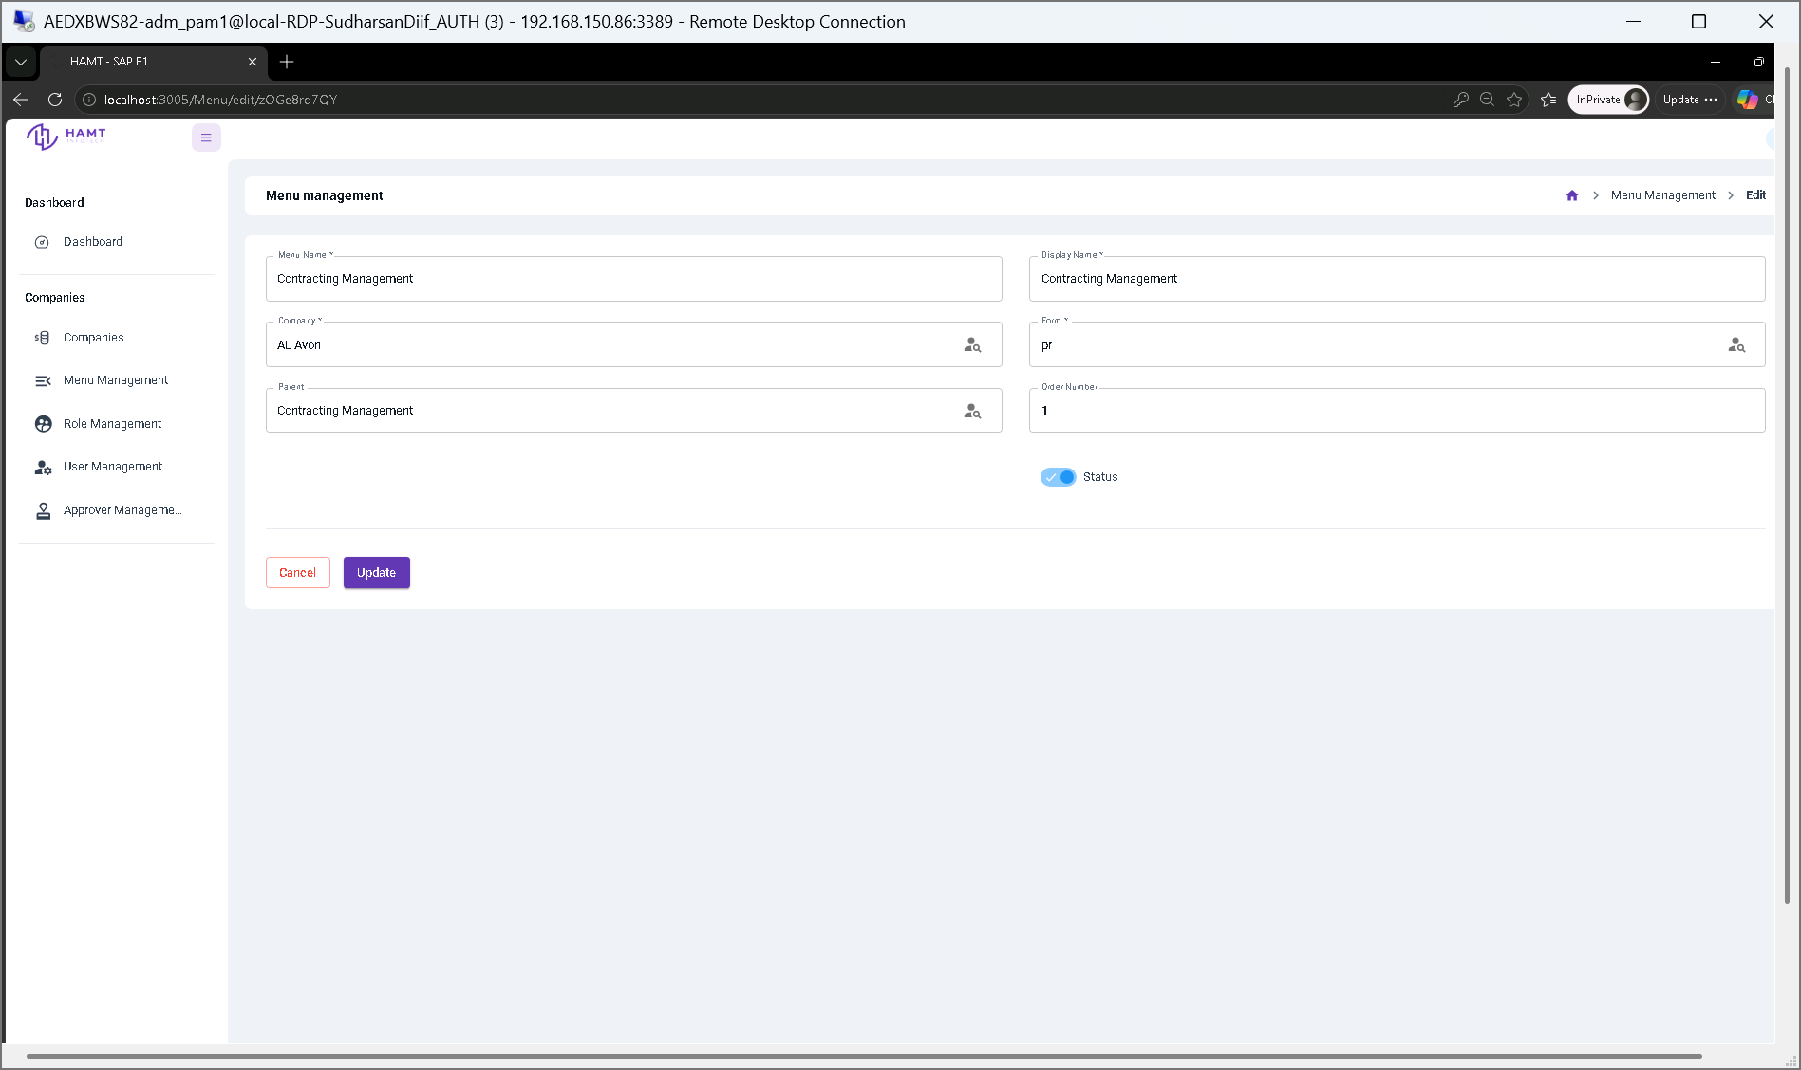
Figure 28: Interface for updating existing navigation routes, display labels, parent menu bindings, and activation switches.

7.3.3.20 View Menu Details
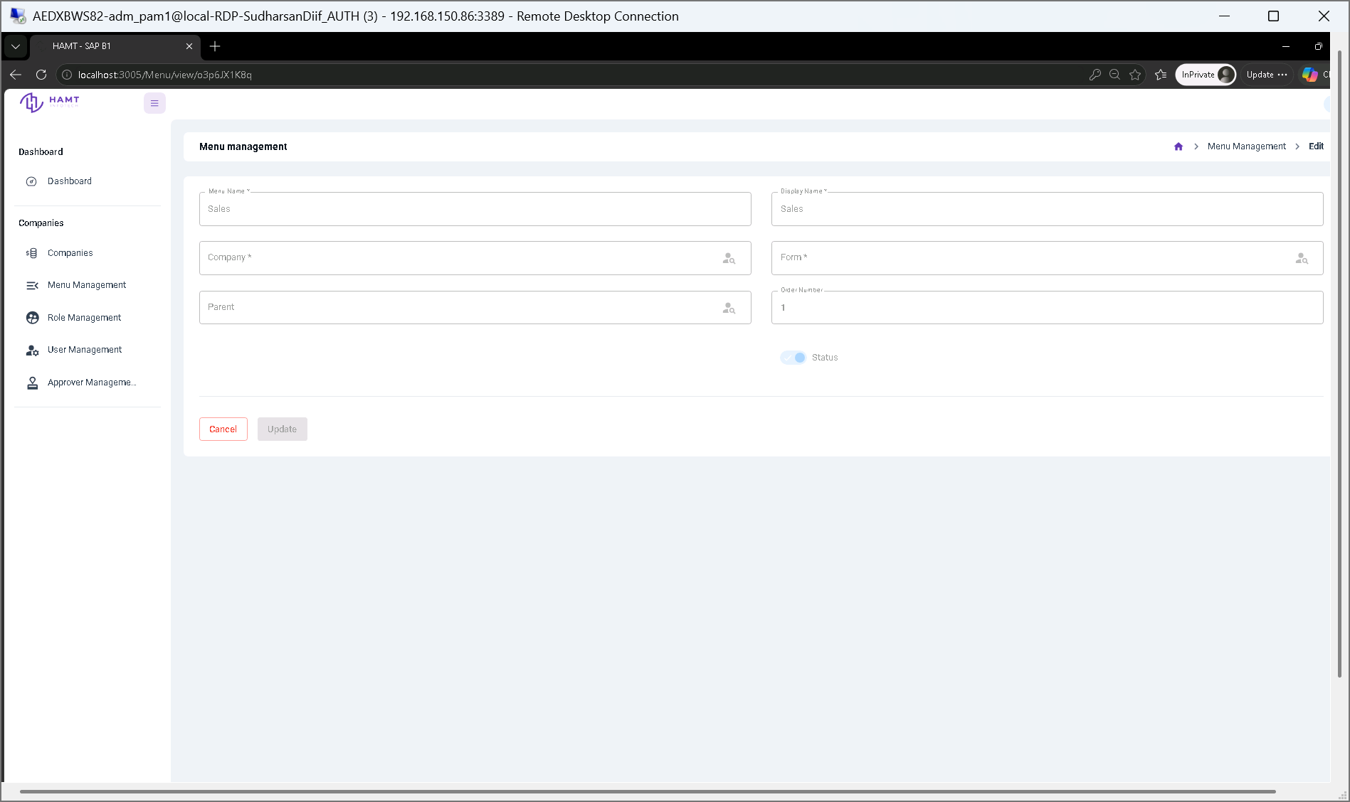
Figure 29: Read-only summary view of a navigation menu item showing its parent hierarchy, form mapping, and display position.

7.3.3.21 Role Management List
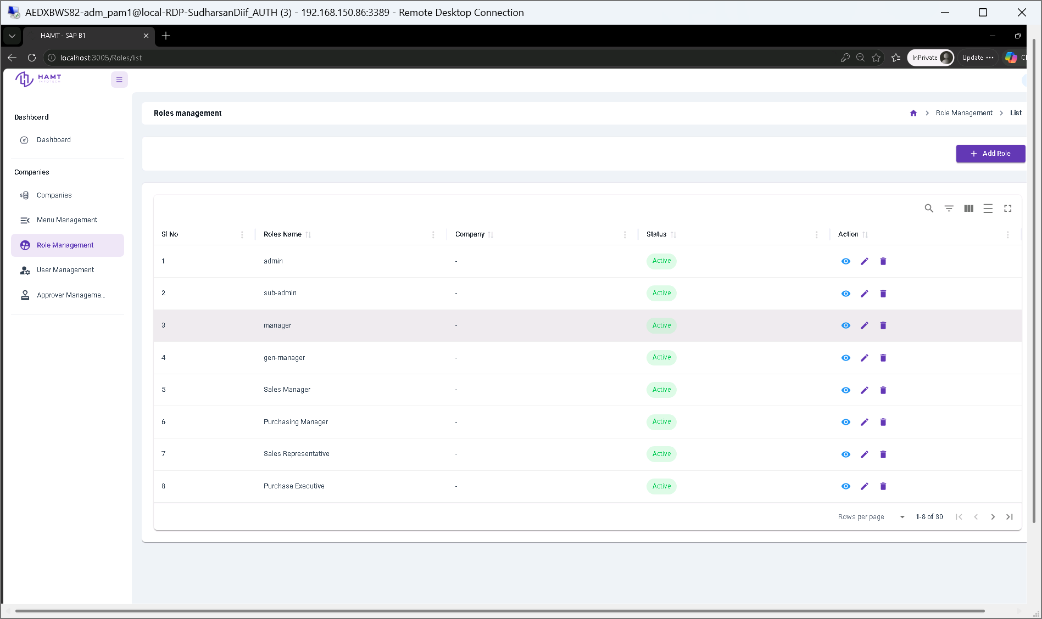
Figure 30: System role overview table listing user roles, company scoping, activation statuses, and management options.

7.3.3.22 Create User Role & Permission Matrix
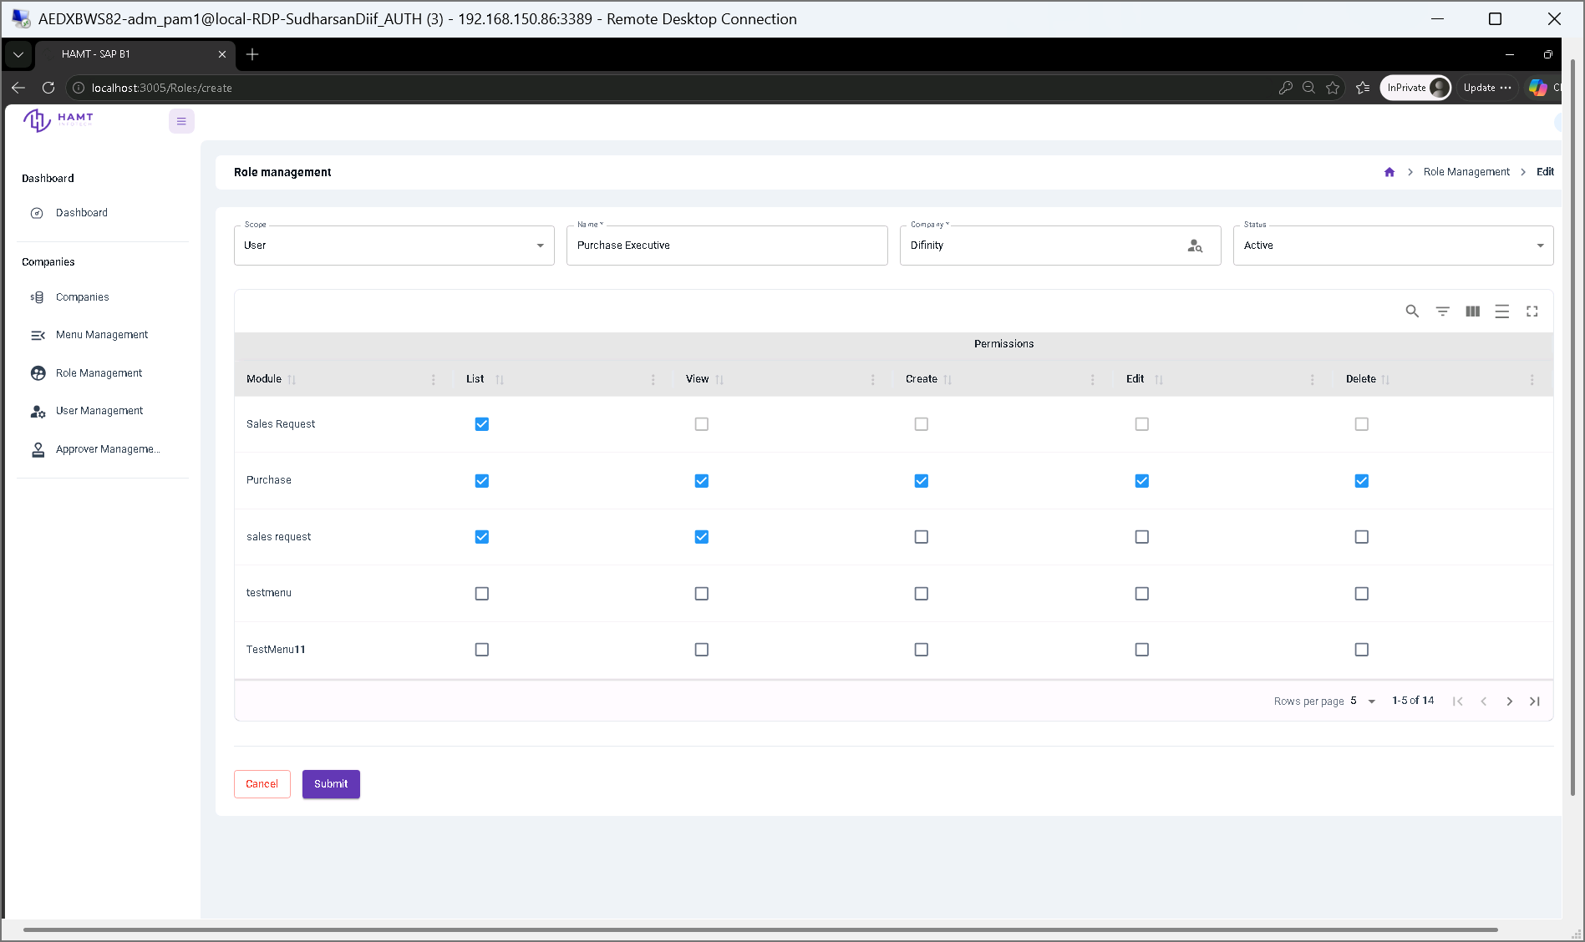
Figure 31: Role definition screen for assigning functional module permissions (List, View, Create, Edit, Delete) for standard user accounts.

7.3.3.23 Create Master Admin Role
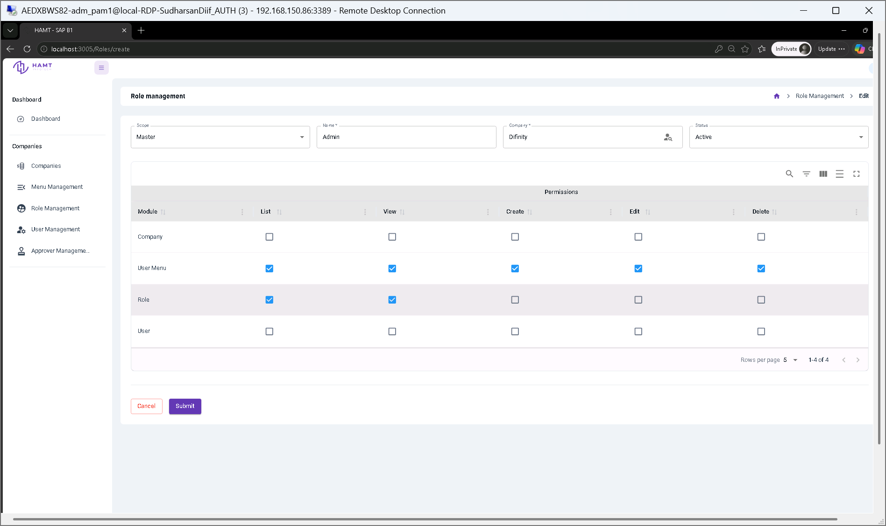
Figure 32: Master role creation interface for configuring elevated system administration and platform governance permissions.

7.3.3.24 Edit Role Permissions
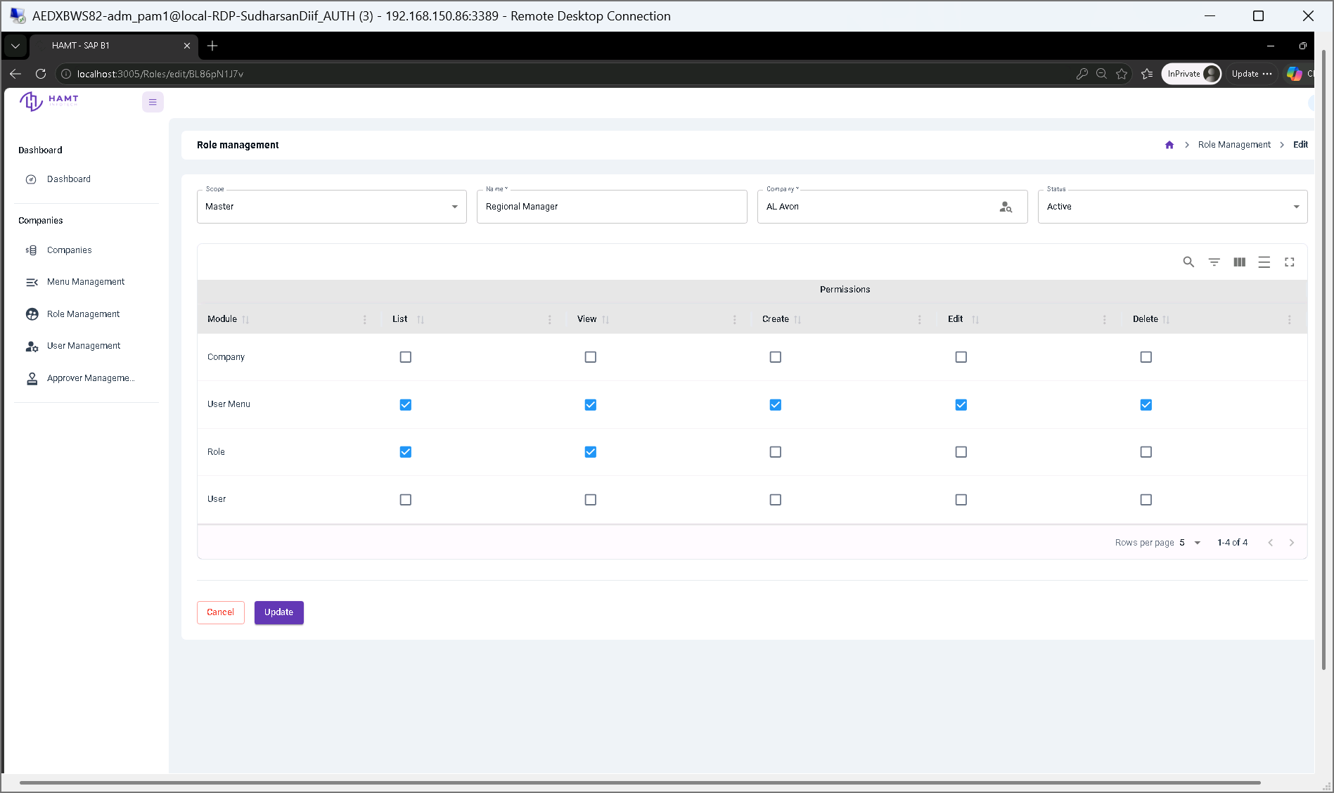
Figure 33: Permission editor for modifying module-level access controls and tenant assignment parameters for existing roles.

7.3.3.25 View Role Details
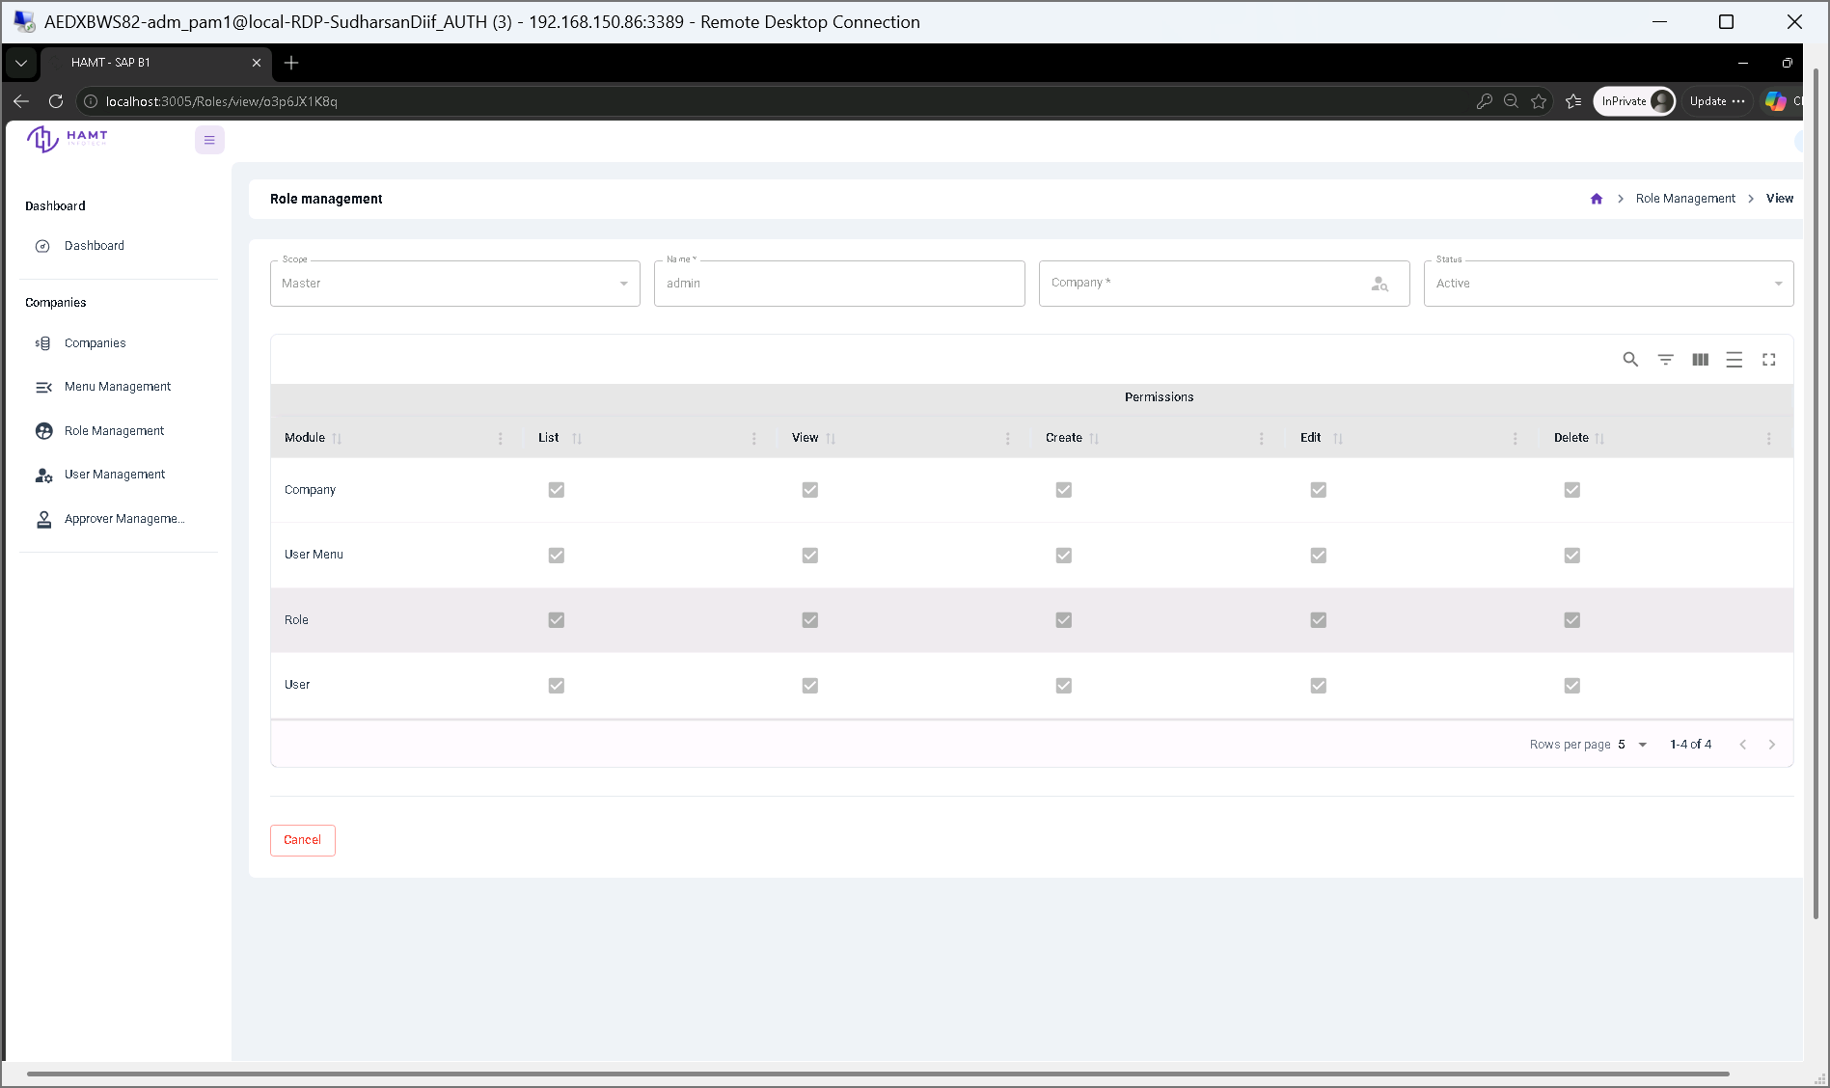
Figure 34: Read-only permission summary view detailing granted operations across system modules for a selected role.

7.3.3.26 User Management List
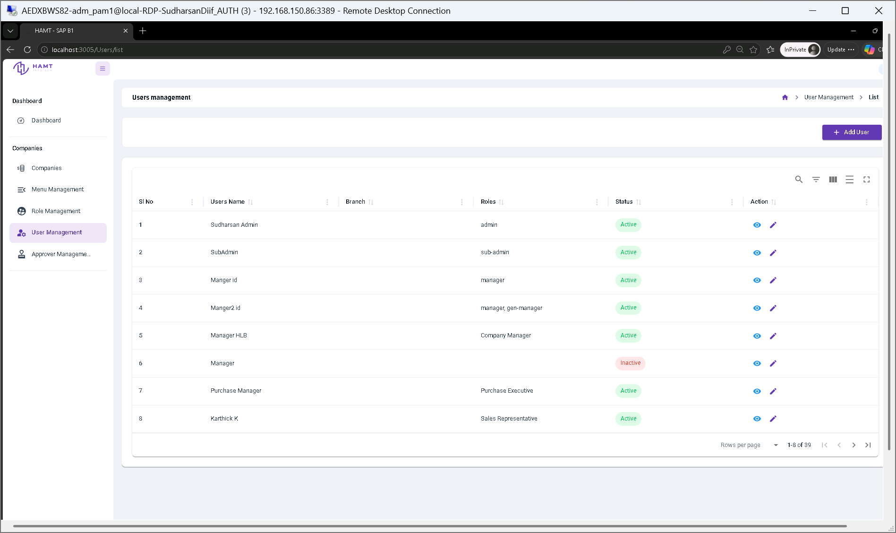
Figure 35: User directory table displaying account names, assigned roles, company/branch affiliations, and active statuses.

7.3.3.27 Create New User
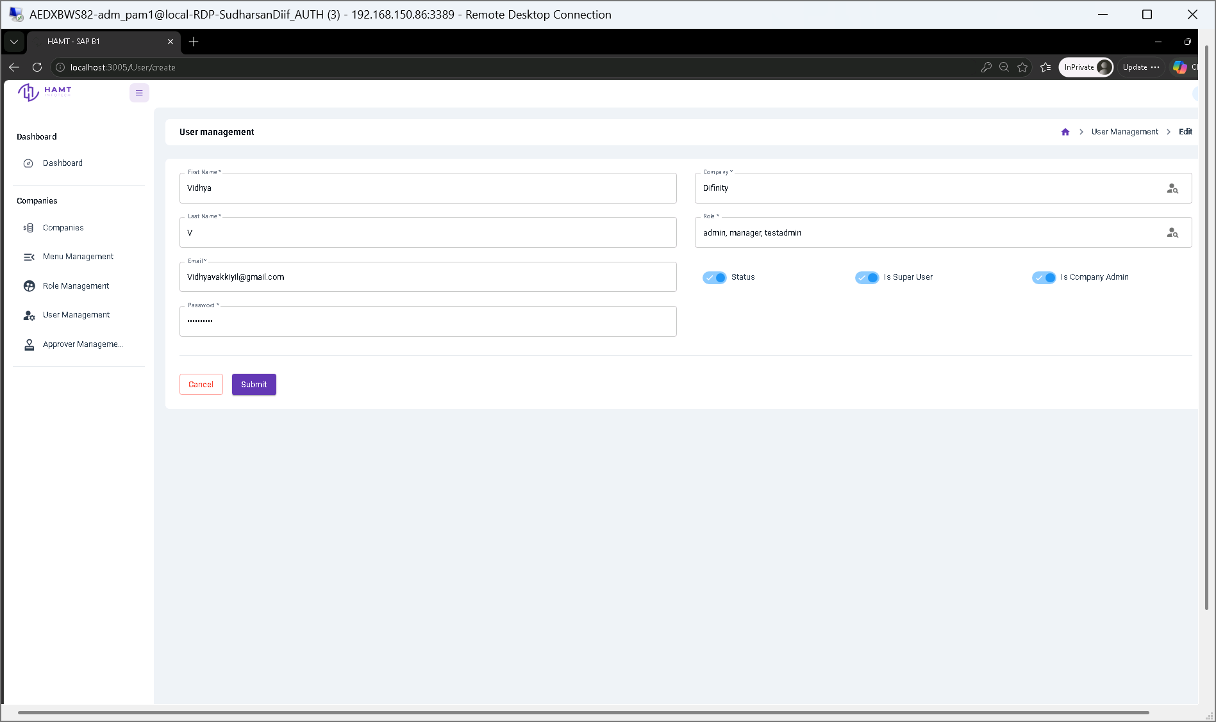
Figure 36: User account provisioning form for setting personal details, credentials, company assignments, assigned roles, and super user flags.

7.3.3.28 Edit User Profile & Access Settings
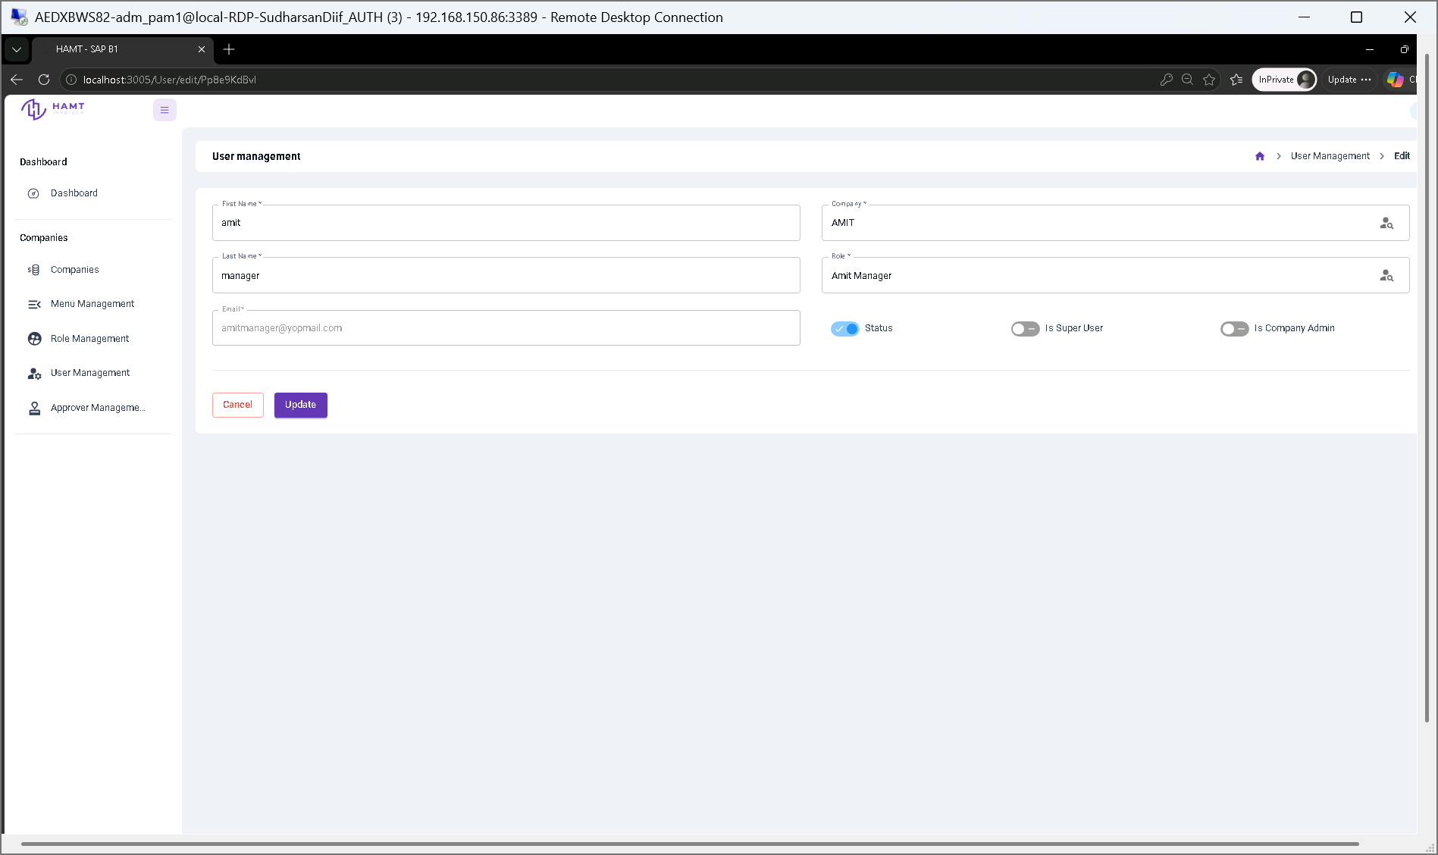
Figure 37: User profile editor for updating contact info, role assignments, tenant association, and administrative privileges.

7.3.3.29 View User Account Details
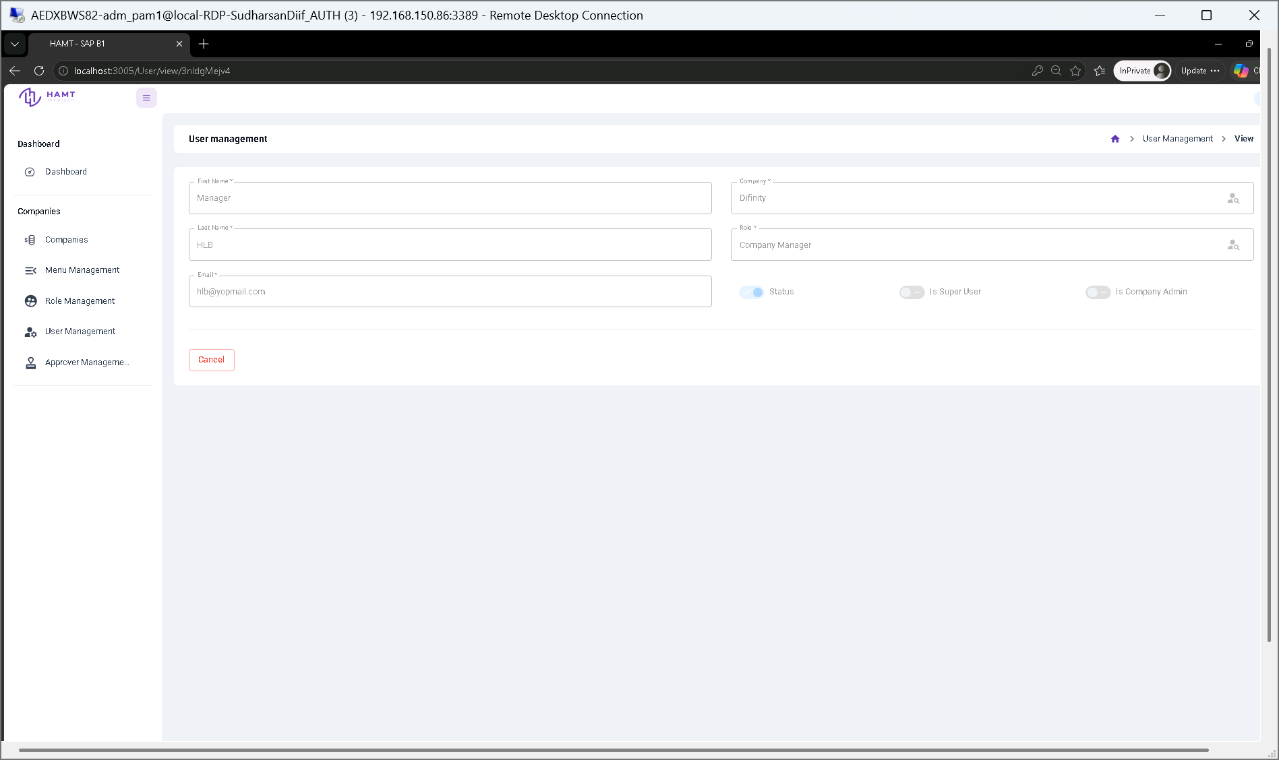
Figure 38: Read-only view displaying user profile information, role assignments, company association, and account flags.

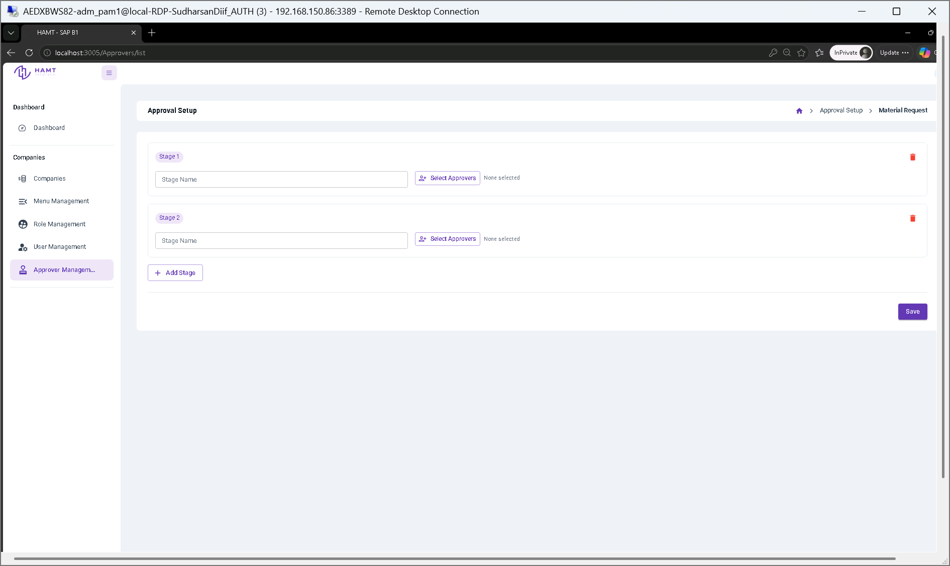
Figure 39: Multi-stage approval rule setup configuration interface for defining approver chains and stage parameters.

